CDPHE O&G EMIS + EPA2011 O&G Spatial | CDPHE O&G EMIS + EPA2014 O&G Spatial
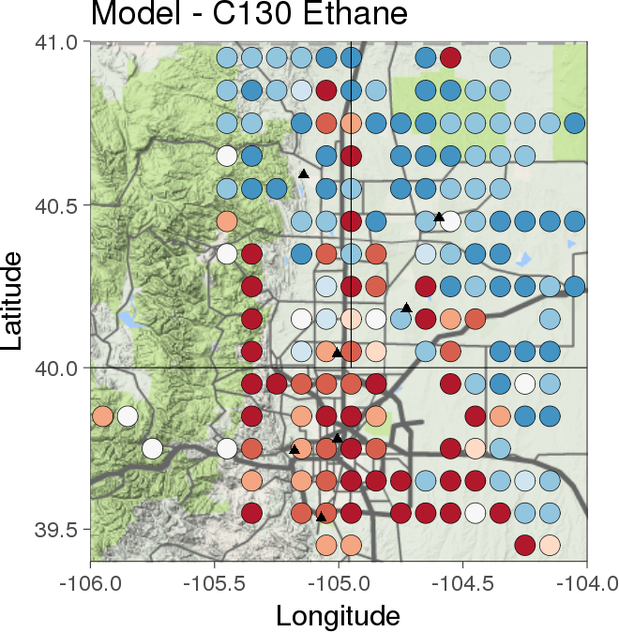 | 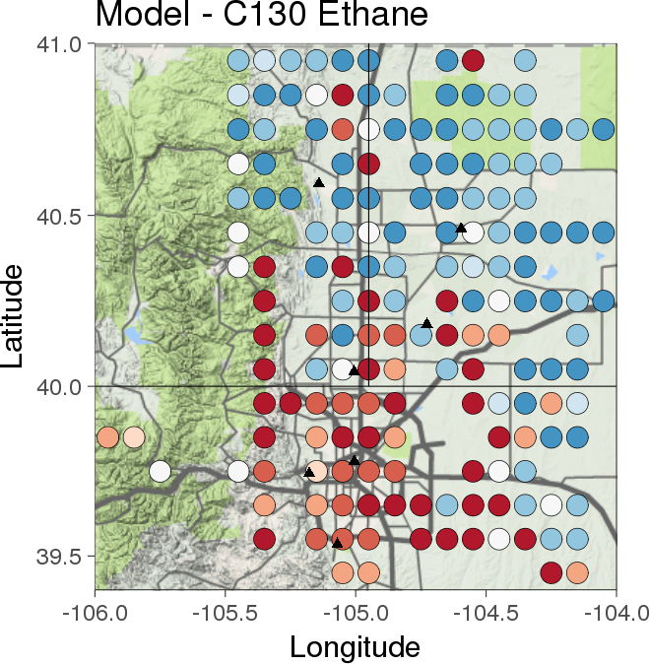
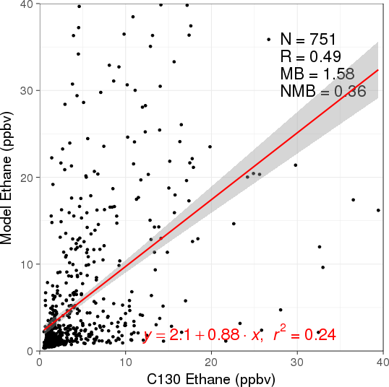 | 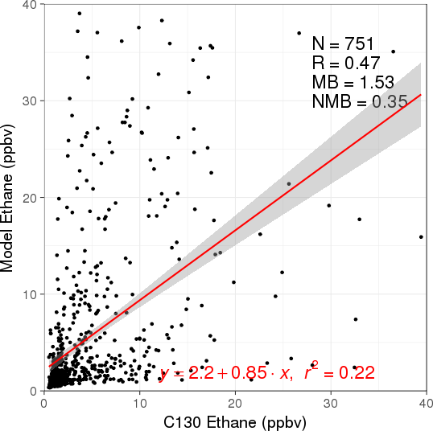

CDPHE O&G EMIS + EPA2011 O&G Spatial | CDPHE O&G EMIS + EPA2014 O&G Spatial
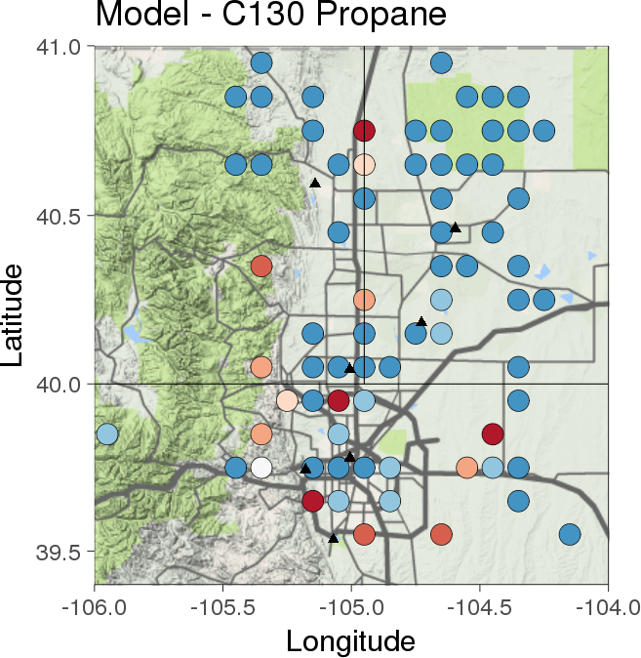 | 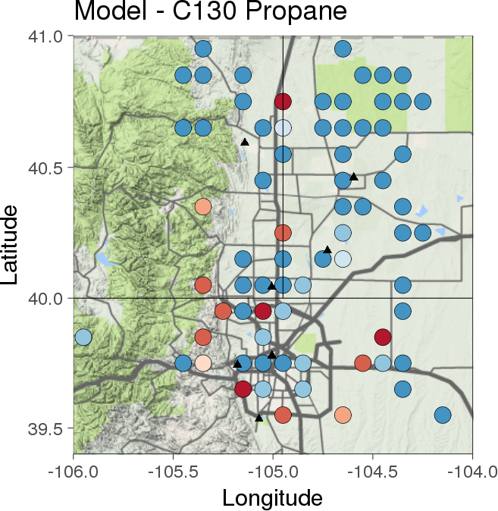
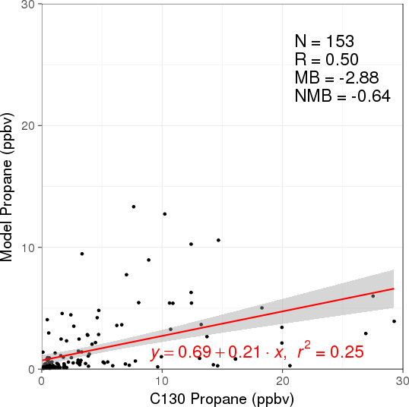 | 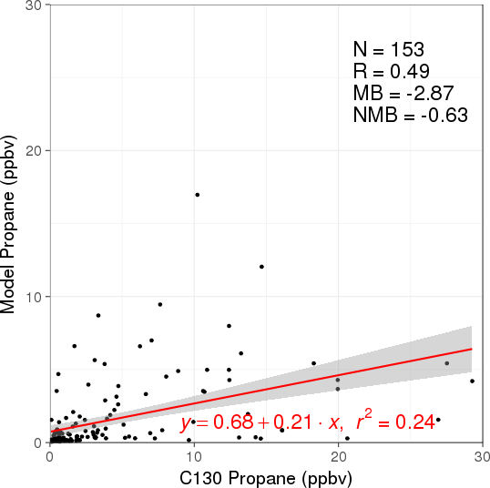

CDPHE O&G EMIS + EPA2011 O&G Spatial | CDPHE O&G EMIS + EPA2014 O&G Spatial
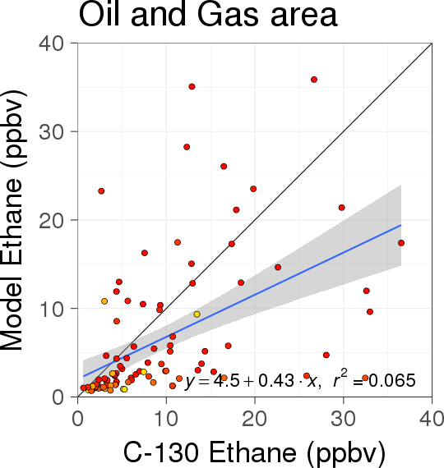 | 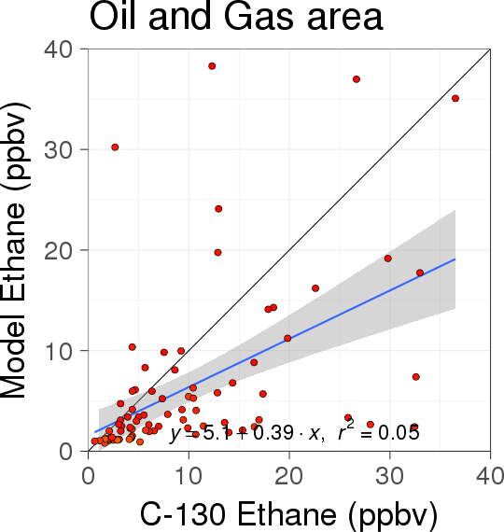
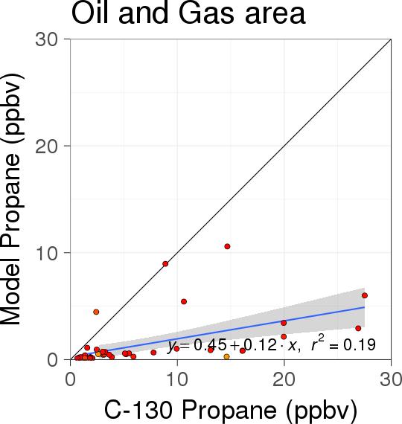 | 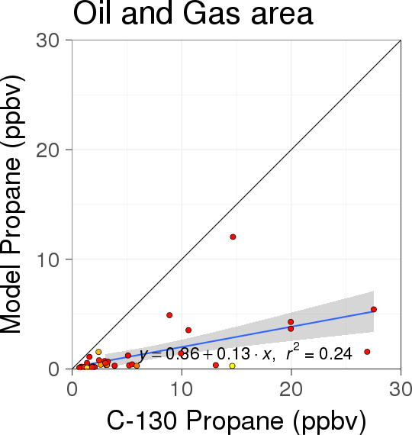

CDPHE O&G EMIS + EPA2011 O&G Spatial | CDPHE O&G EMIS + EPA2014 O&G Spatial
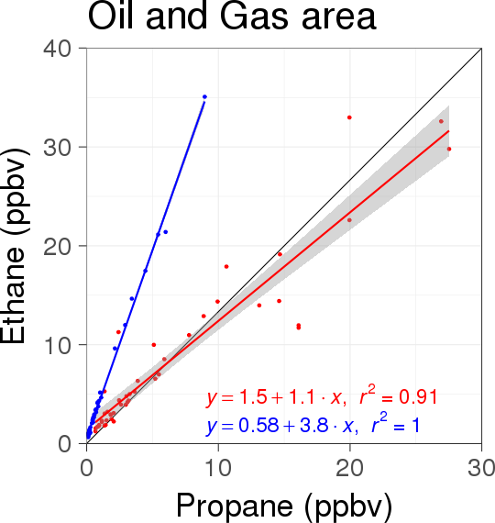 | 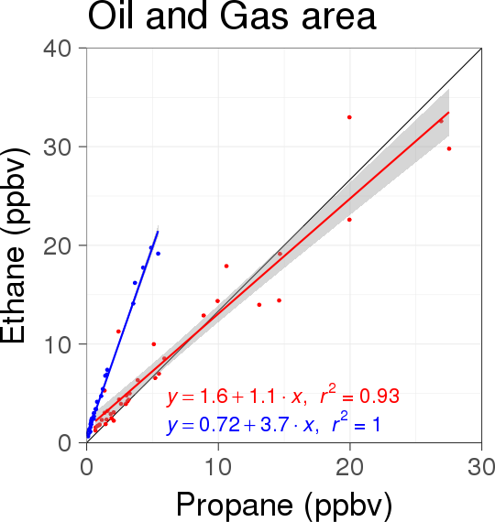
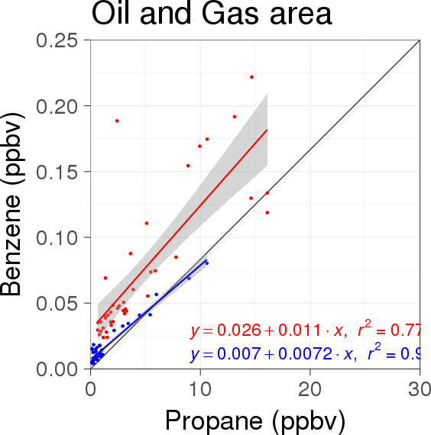 | 