Speciation

Model Species name | Description | Observation mapping
NTR1 | Simple organic nitrates | EthylNitrate_TOGA + i-PropylNitrate_TOGA + tert-ButylNitrate_TOGA + 2-ButylNitrate_n-ButylNitrate_TOGA + 2-PentylNitrate_3-PentylNitrate_TOGA
KET | Ketone carbon bond | MEK_TOGA
PAR | Paraffin carbon bond | TOGA:  4*n-Butane_TOGA + 4*i-Butane_TOGA + 5*i-Pentane_TOGA + 5*n-Pentane_TOGA + 5*2-Methylpentane_TOGA + 5*3-Methylpentane_TOGA + 6*n-Hexane_TOGA + 7*n-Heptane_TOGA + 3*MEK_TOGA  WAS:  4*n-Butane_WAS + 4*i-Butane_WAS + 5*i-Pentane_WAS + 5*n-Pentane_WAS + 5*2-Methylpentane_WAS + 5*3-Methylpentane_WAS + 6*n-Hexane_WAS + 7*n-Heptane_WAS + 4*2-2-Dimethylbutane_WAS + 6*2-3-Dimethylbutane_WAS + 5*Cyclopentane_WAS + 6*Methylcyclopentane_WAS+ 6*Cyclohexane_WAS + 7*Methylcylohexane_WAS + 7*2-4-Dimethylpentane_WAS + 7*2-2-4-Trimethylpentane_WAS + 8*n-Octane_WAS
PRPA | Propane | Propane_WAS
ETHY | Ethyne | Ethyne_WAS
ETH | Ethene | Ethene_WAS
OLE | Terminal olefin carbon bond (R‐C=C) | Propene_WAS + i-Butene_n-Butene_TOGA

TOGA PAR vs WAS PAR
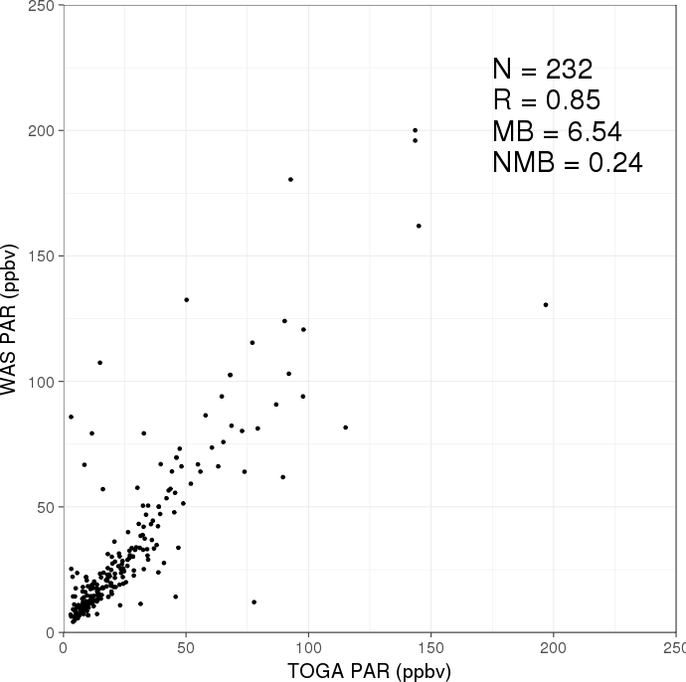

-> I used averaged PAR using TOGA and WAS

Cherokee powerplant (39.808, -104.964) +- 0.025

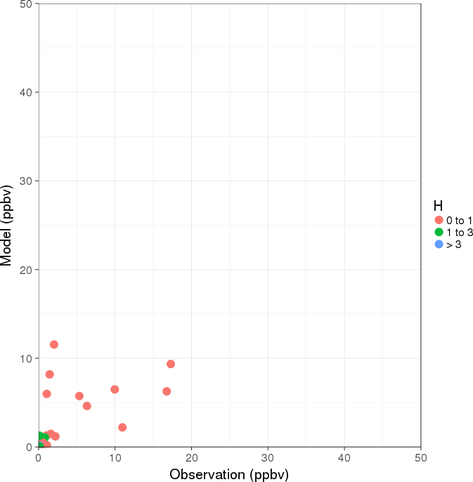 | 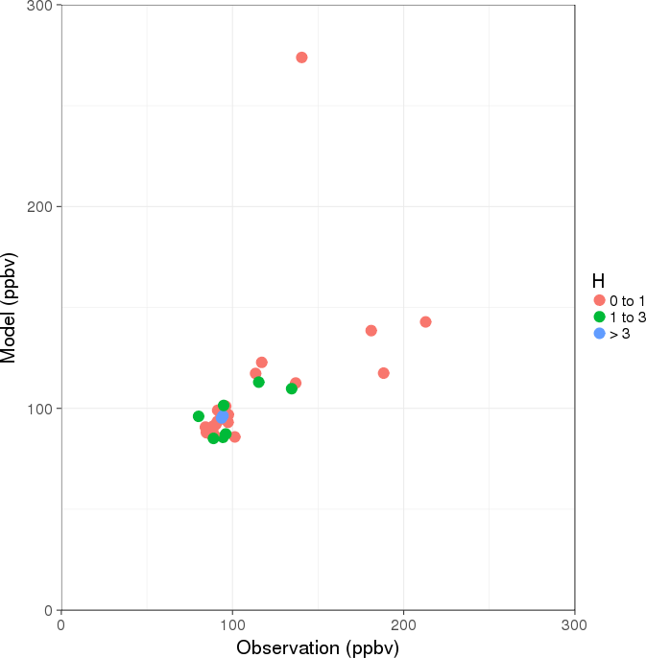 | 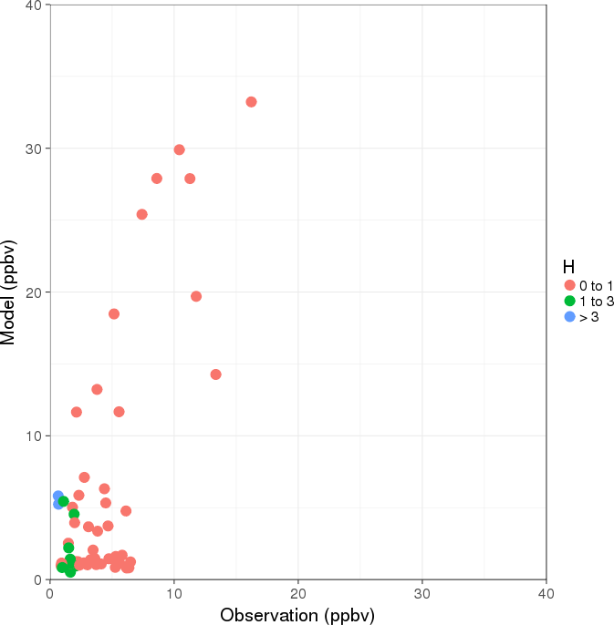
NOx | CO | Ethane
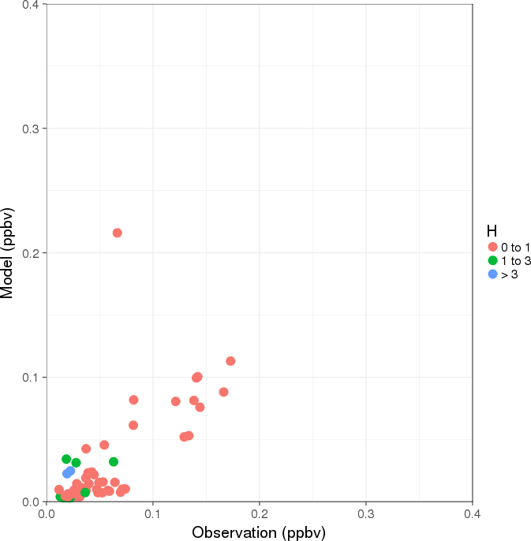 | 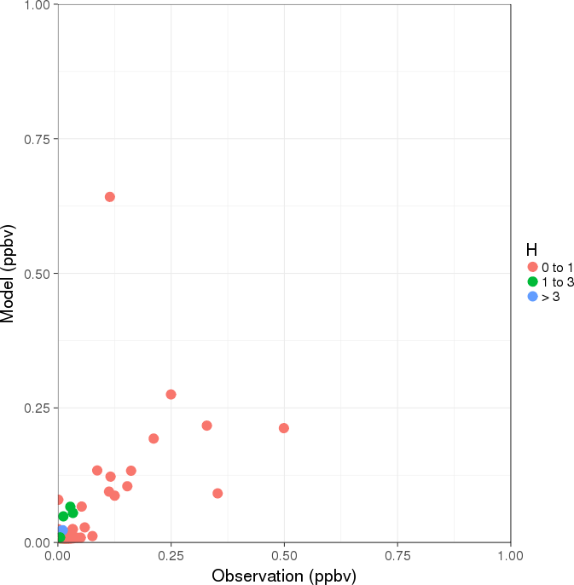 | 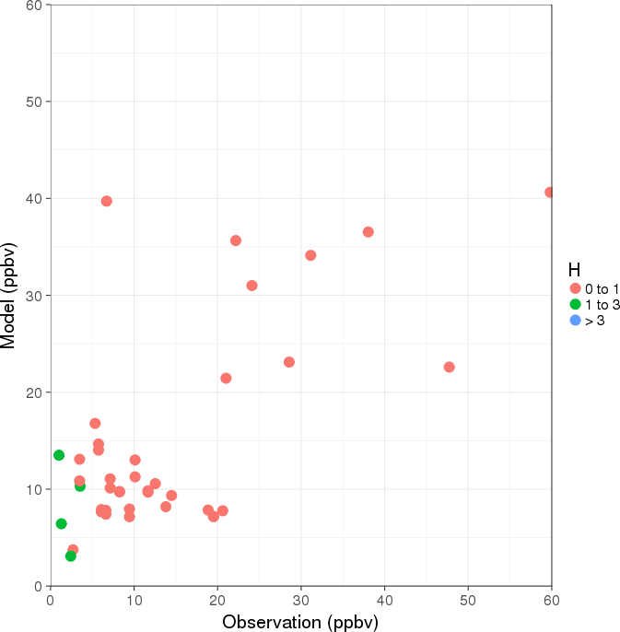
Benzene | Toluene | PAR

CO emission

 | EPA 2014 | EPA 2017 | SIP report | FRAPPE
Area | NNA | NNA | NNA | Front Range (smaller than NNA)
Period | Annual 2014 | Annual 2017 | Annual 2008 | July ~ August 2014
Nonroad mobile | 422.74 | 415.47 | 759.70 | 439.25
Onroad mobile | 656.81 | 493.87 | 554.80 | 508.05
Biogenic | 39.51 | 42.72 | 21.60 | 85.50

* Unit: Ton / day

C130 vs P3B in August
NOx (left: C130, right: P3B)
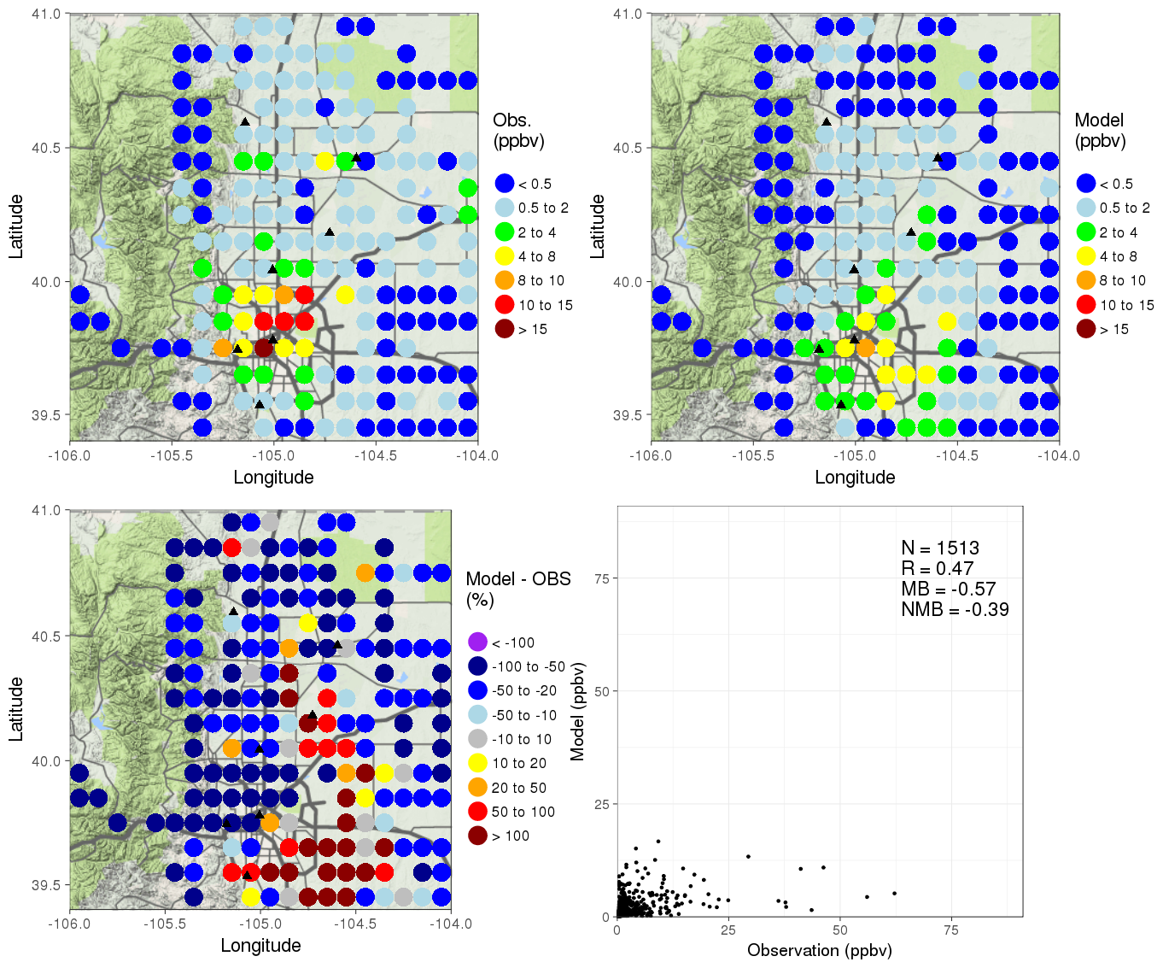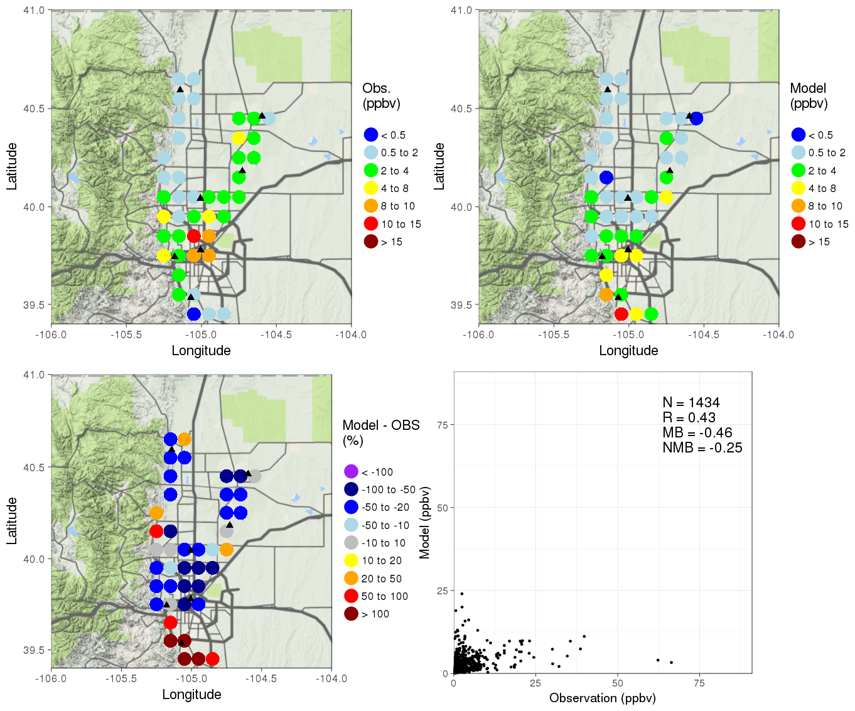

CO (left: C130, right: P3B)
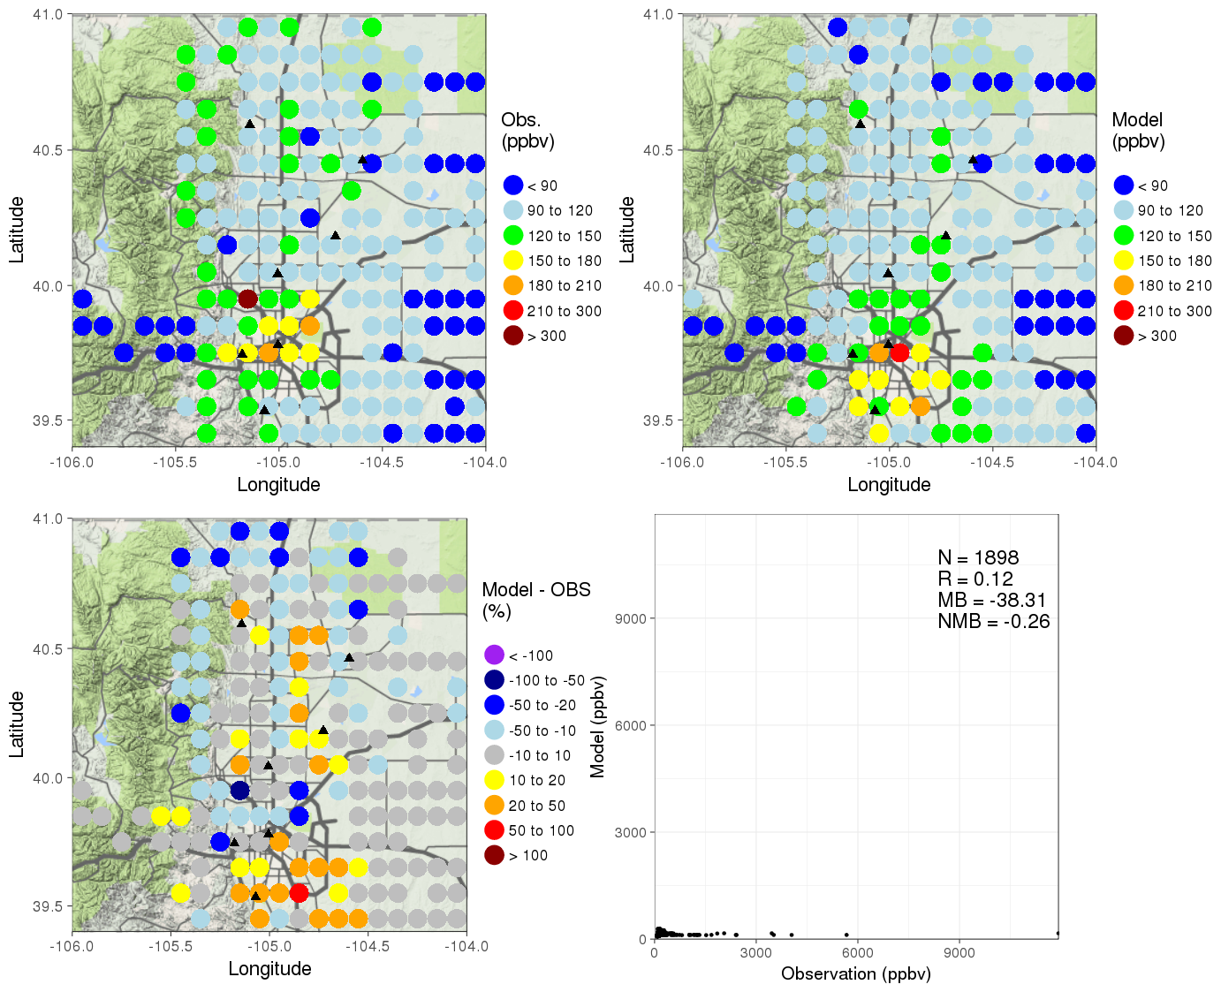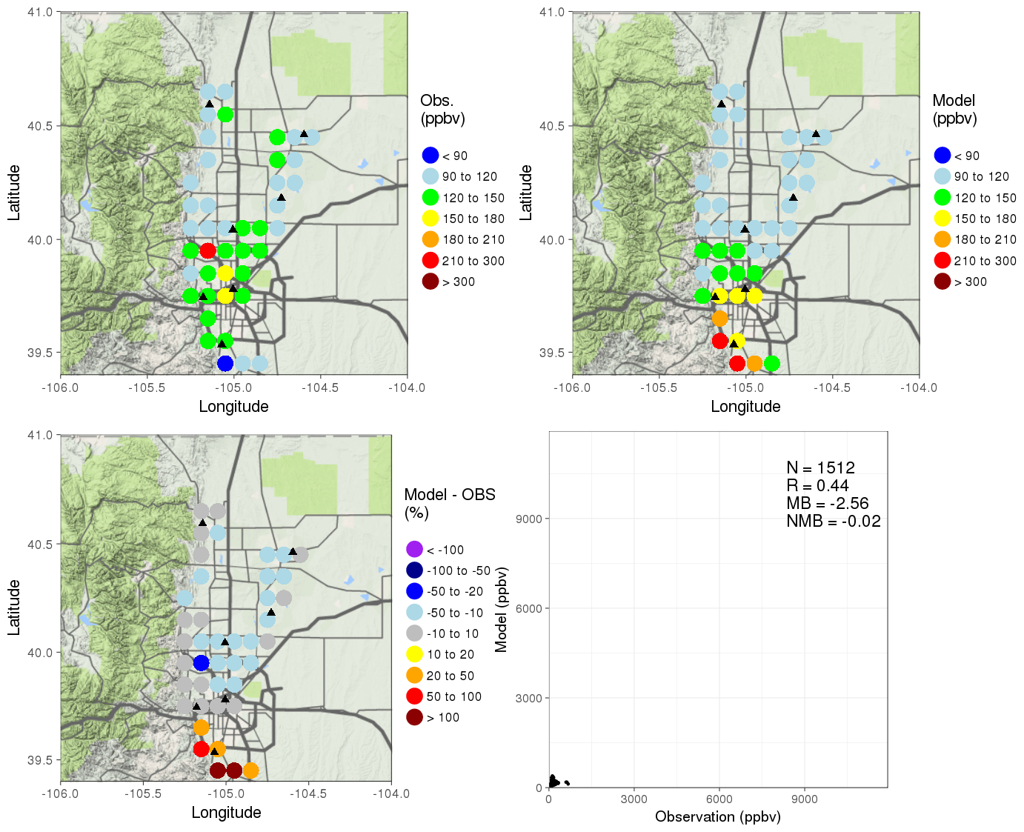

Ethane (left: C130, right: P3B)
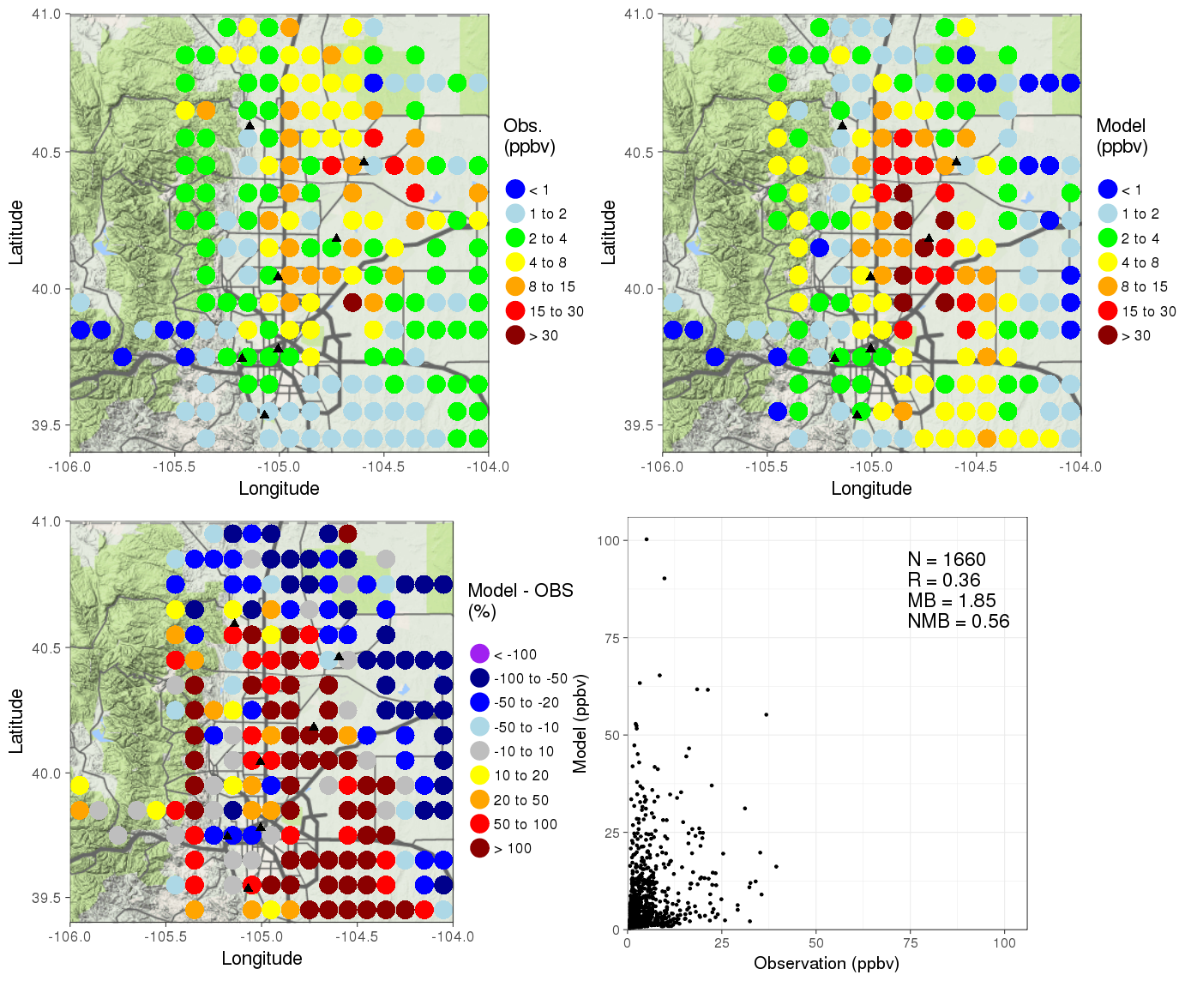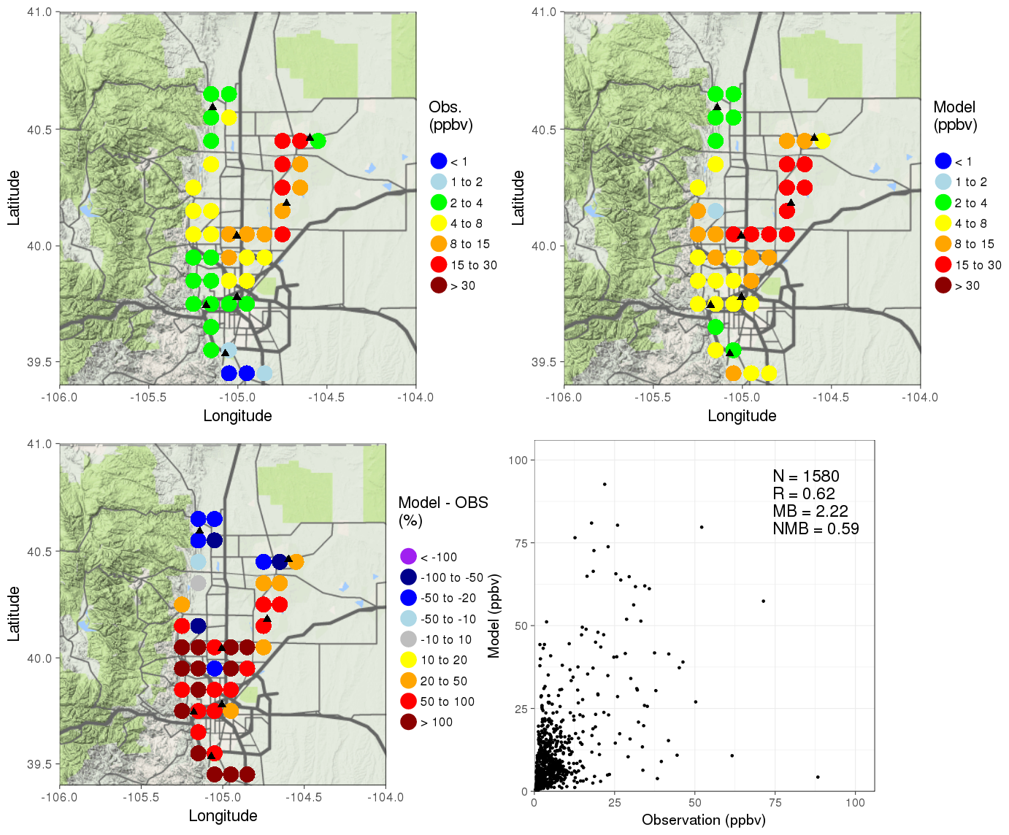

Benzene (left: C130, right: P3B)
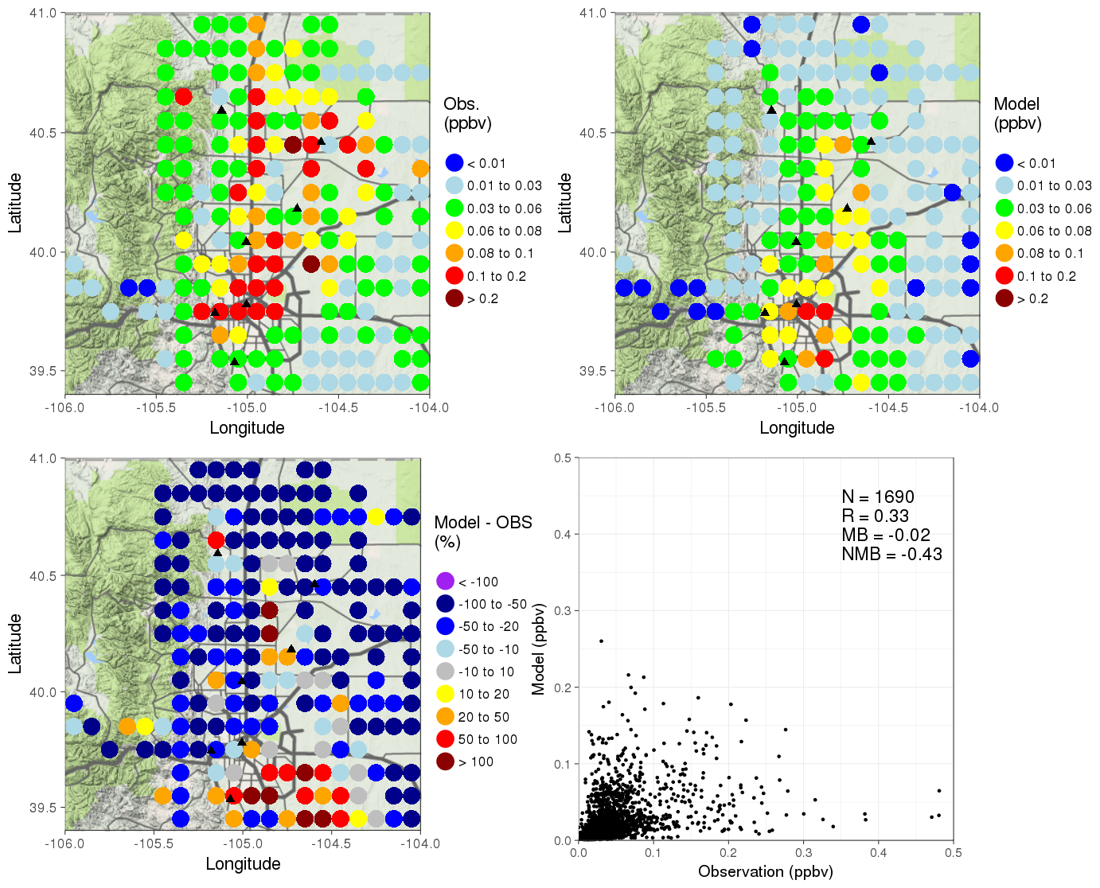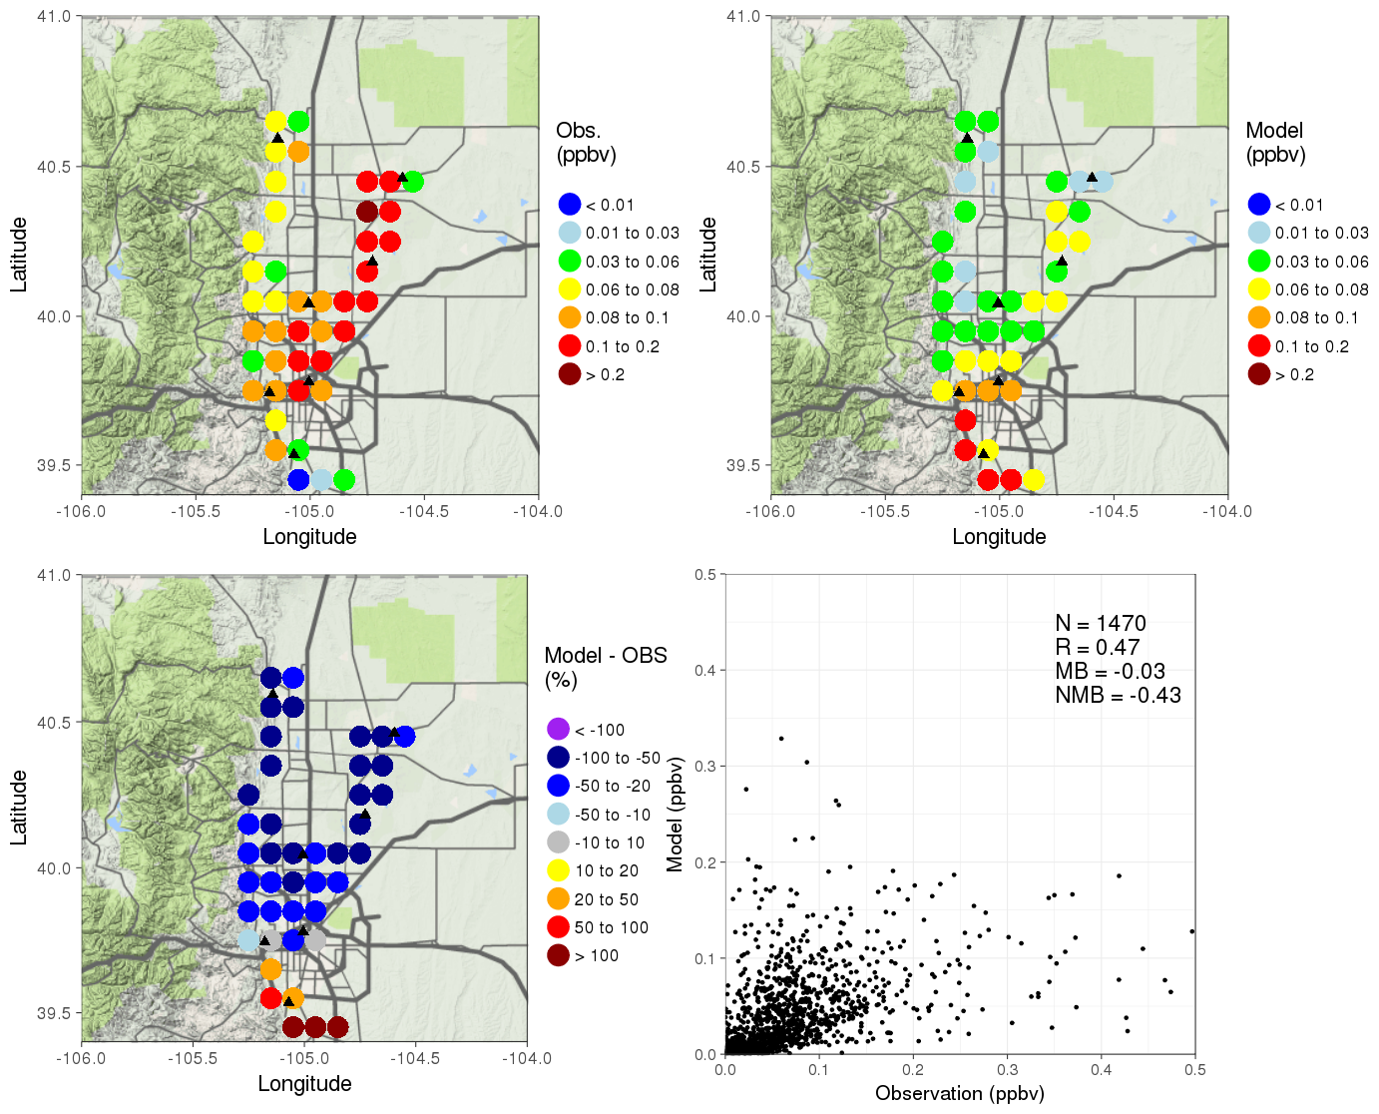

Toluene (left: C130, right: P3B)
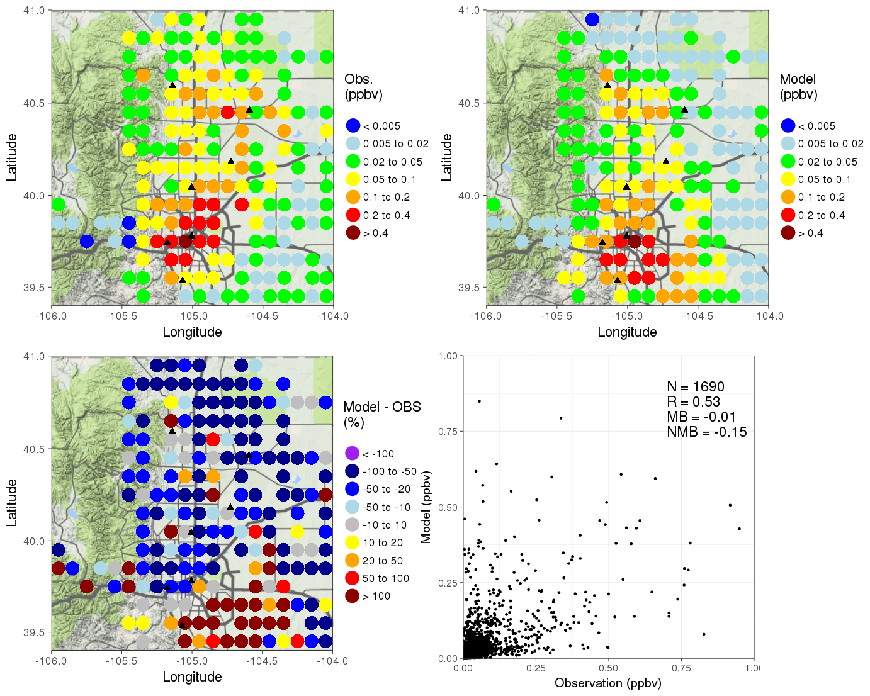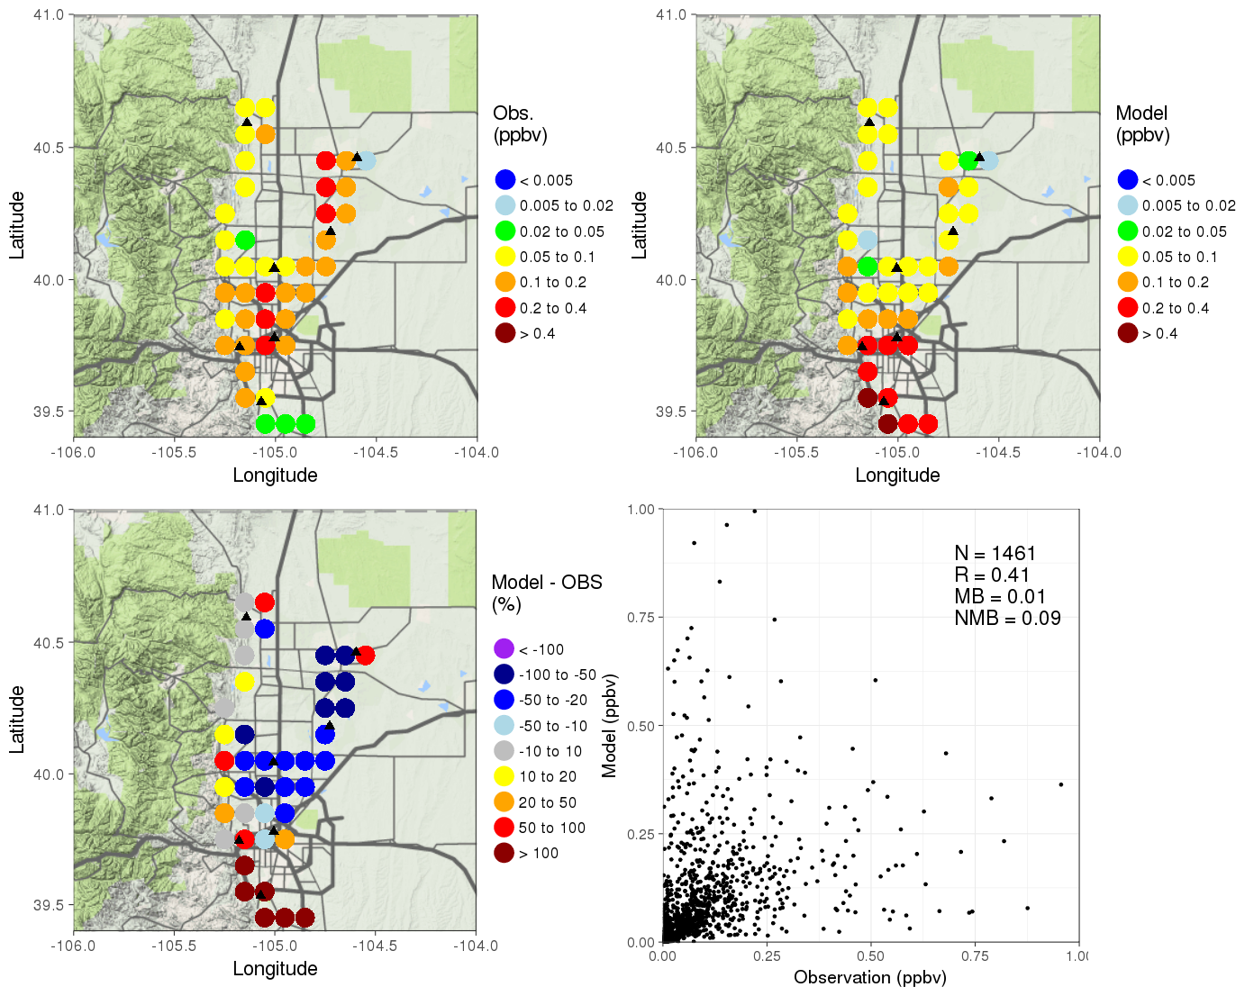

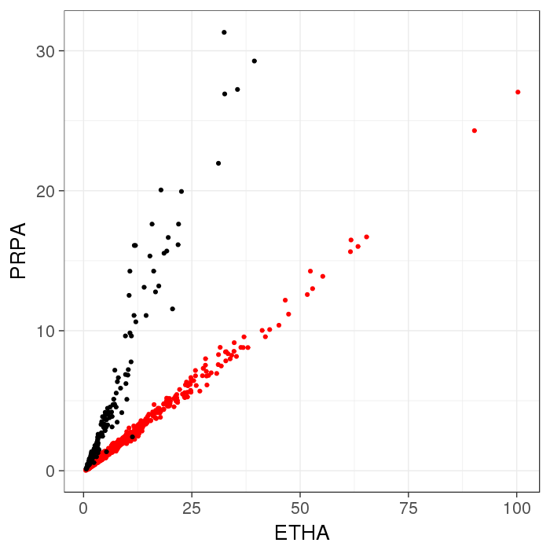
Black: C130 Observation, Red: Model. Below 1 km over Front Range between 10 to 17 local time in August

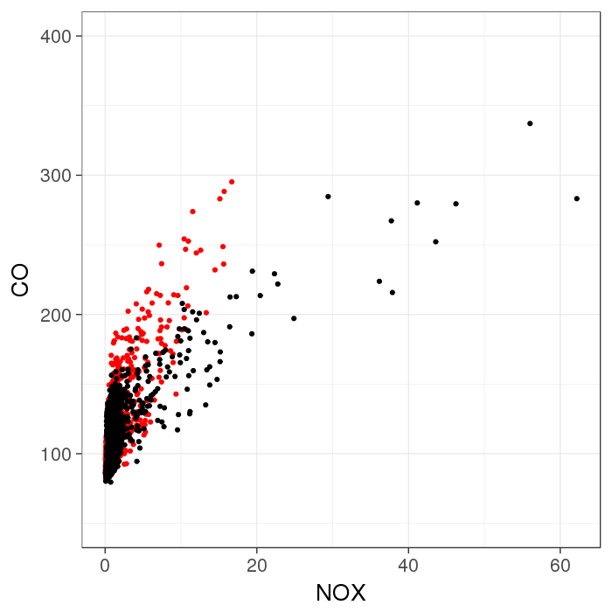
Black: C130 Observation, Red: Model. Below 1 km over Front Range between 10 to 17 local time in August

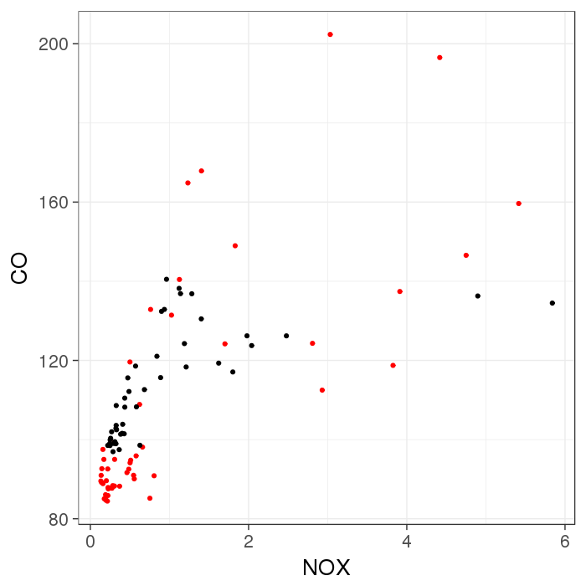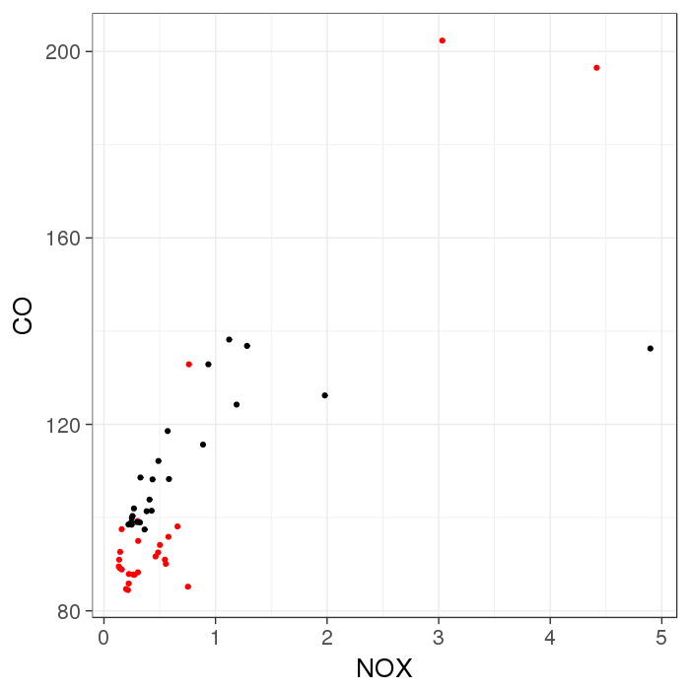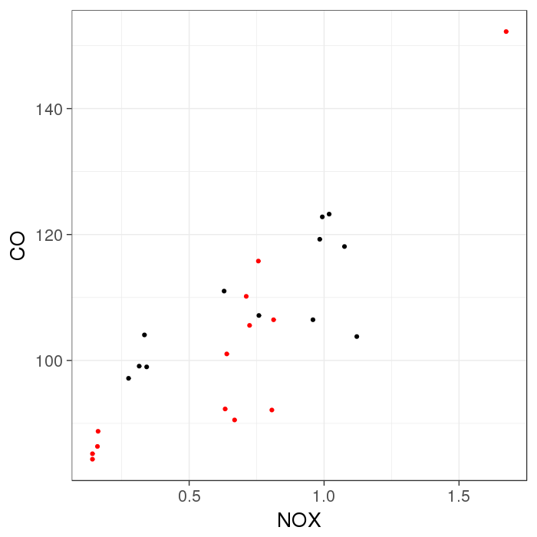
Black: C130 Observation, Red: Model. Below 1 km over Front Range where onroad mobile emissions are larger than 0.5 kg/hour/km^2 (left), nonroad mobile emissions are larger than 0.5 kg/hour/km^2 (middle) and nonpoint oil and gas emissions are larger than 0.1 kg/hour/km^2 (right) between 10 to 17 local time in August

NOx
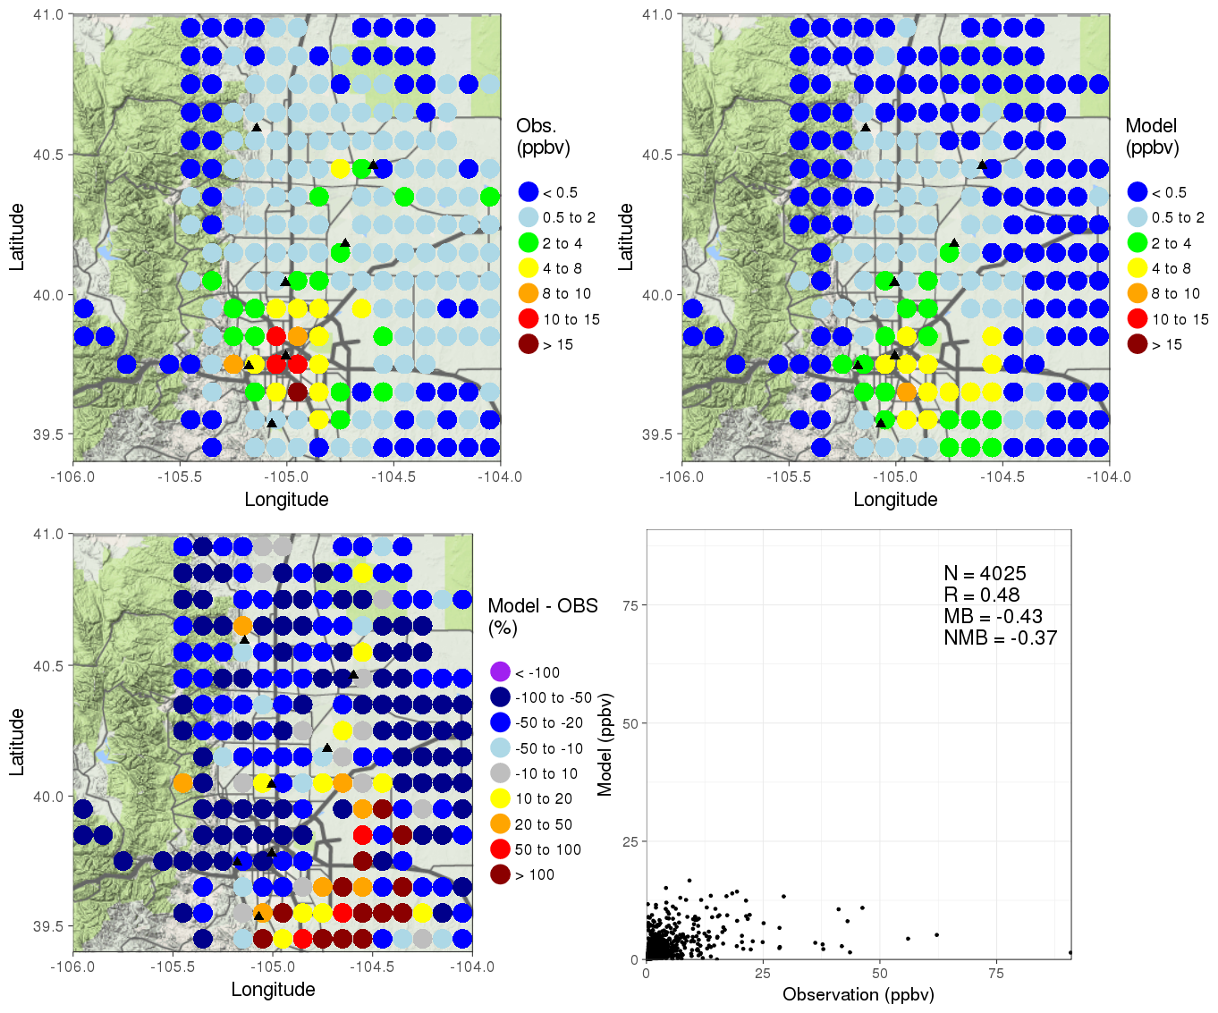

The largest 4 sector emissions of NOx in the Front range

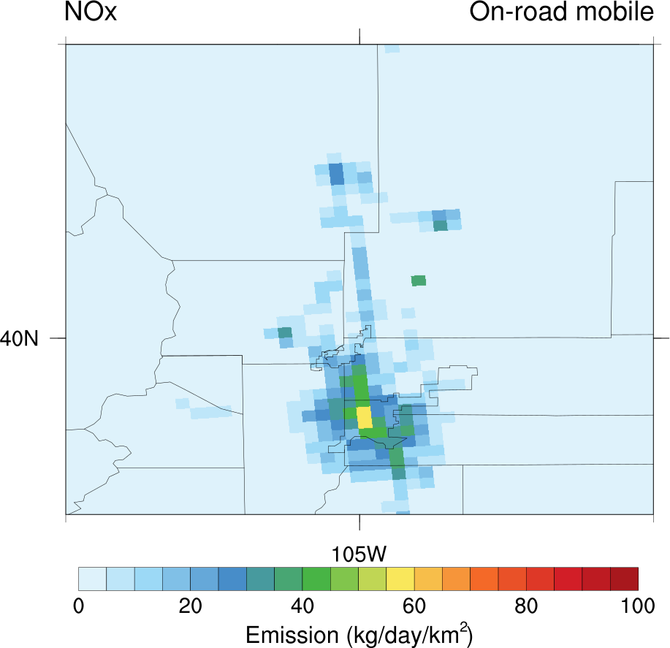 | 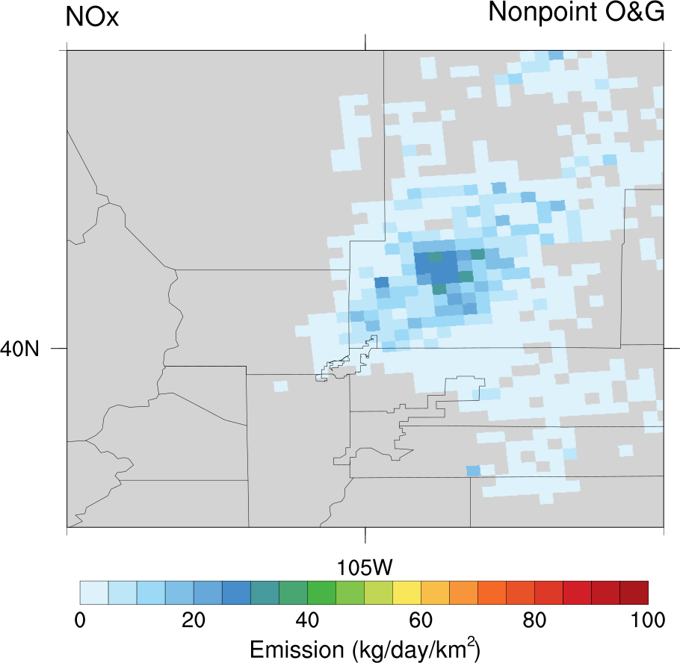 | 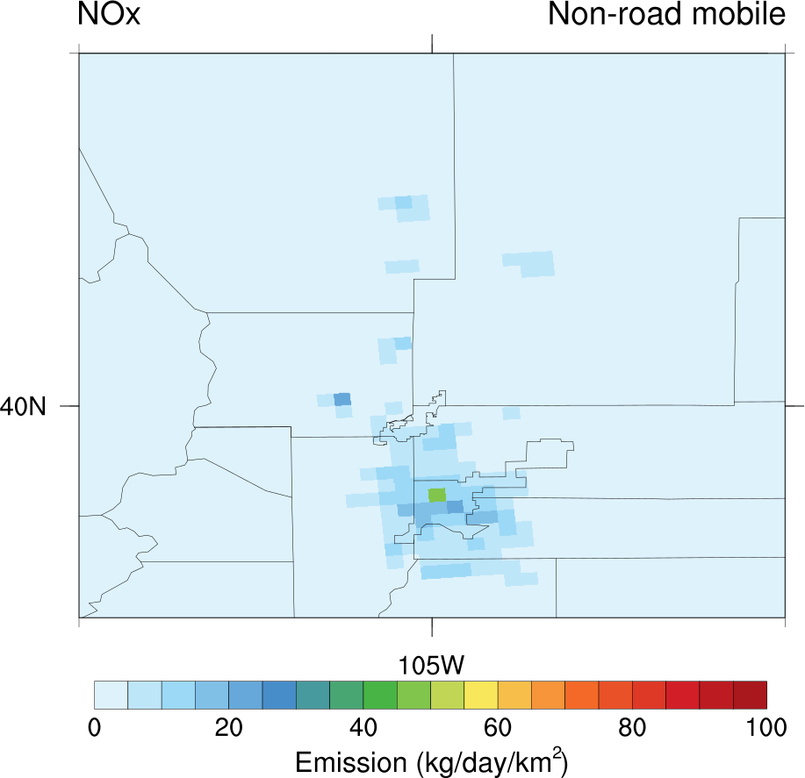 | 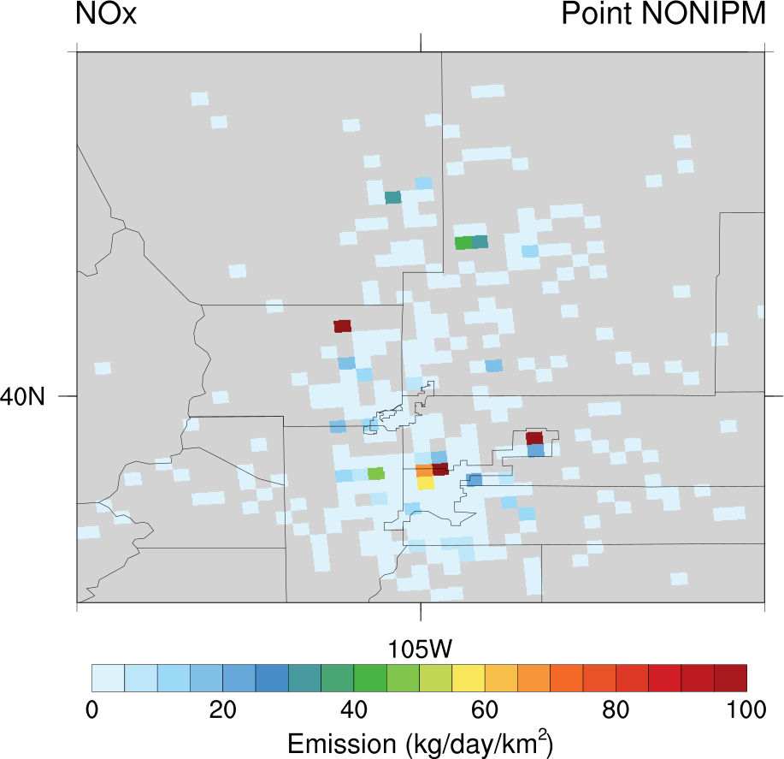
Onroad mobile: 62.33 Ton/day | Nonpoint O&G: 33.03 Ton/day | Nonroad mobile: 26.97 Ton/day | Point NONIPM: 22.08 Ton/day

! Onroad mobile emission -> 40% up, Nonpoint O&G emission -> 40% up

CO
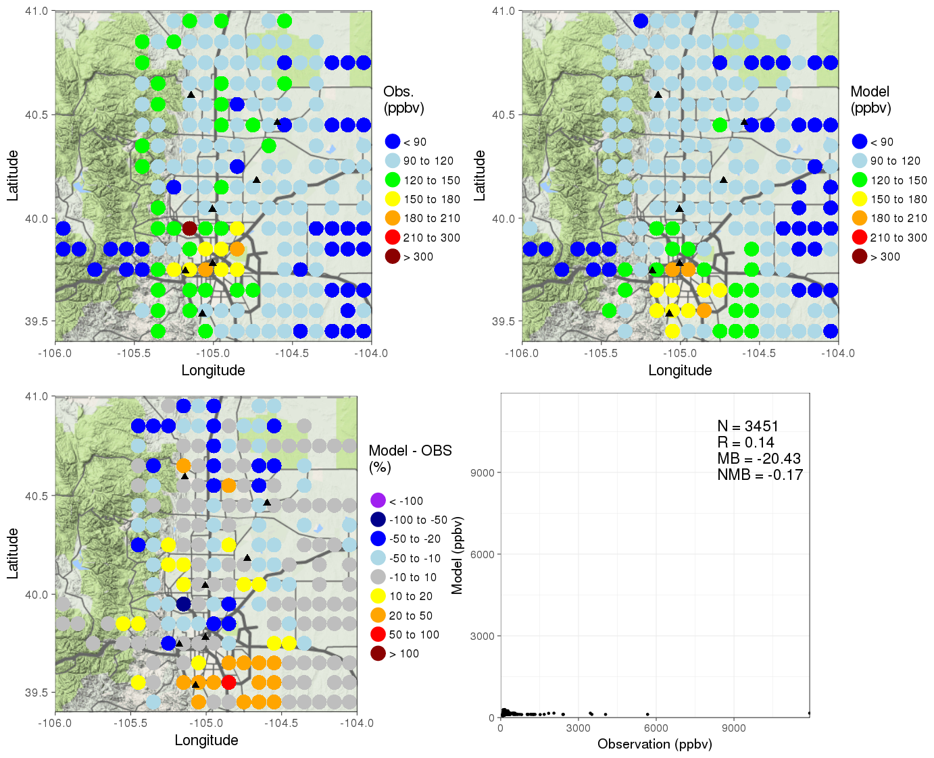

The largest 4 sector emissions of CO in the Front range

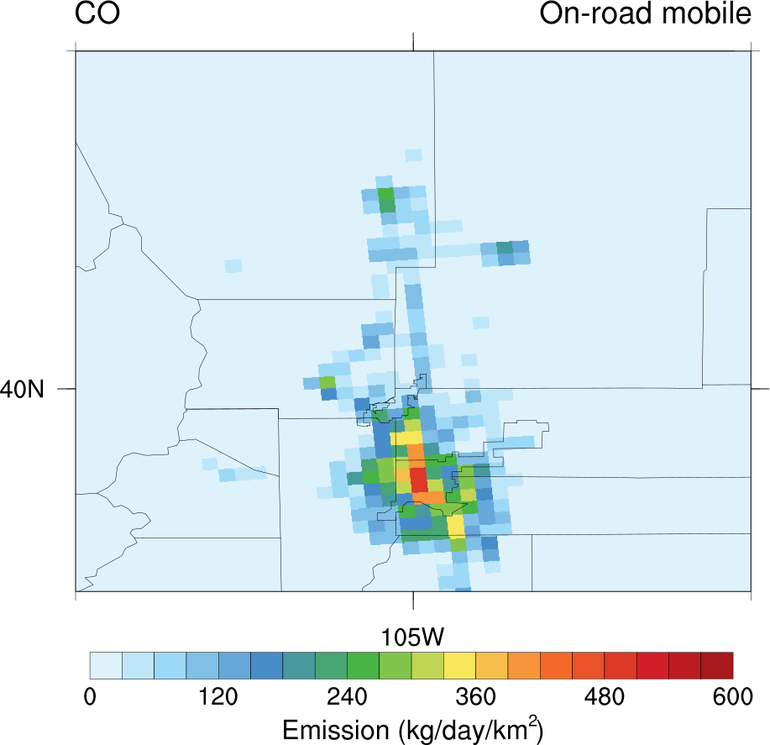 | 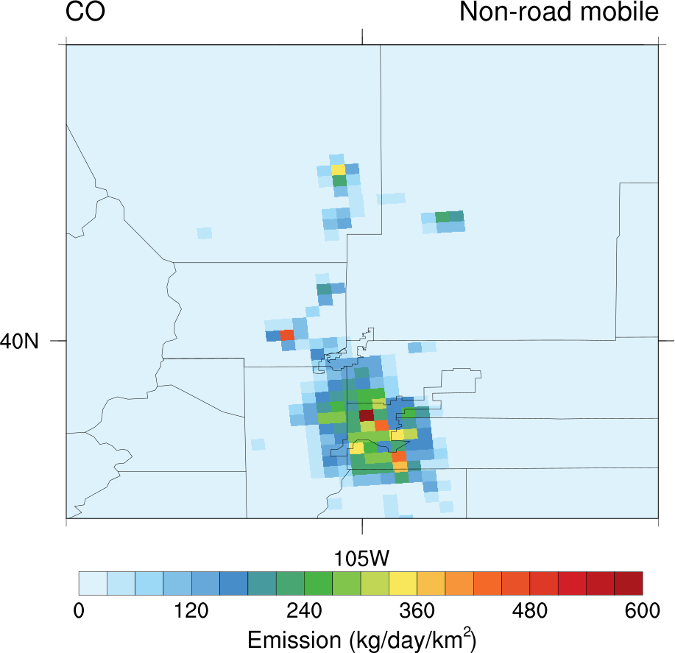 | 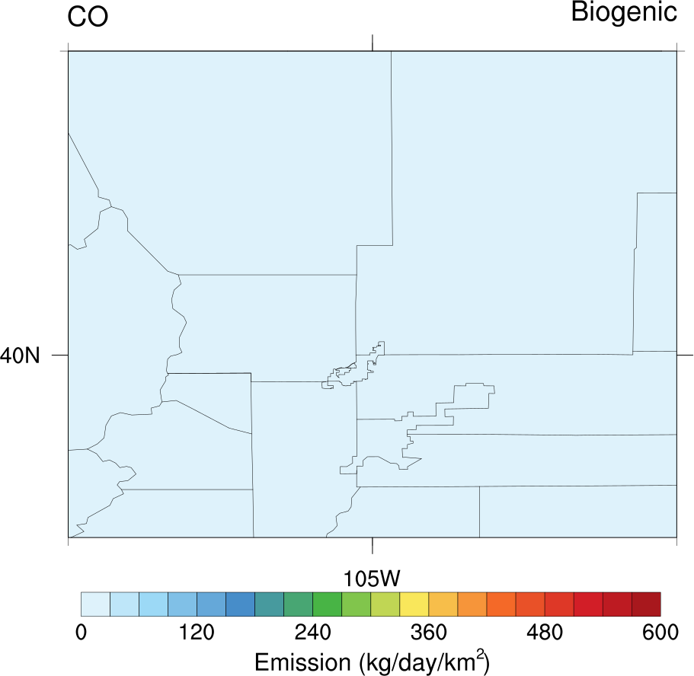 | 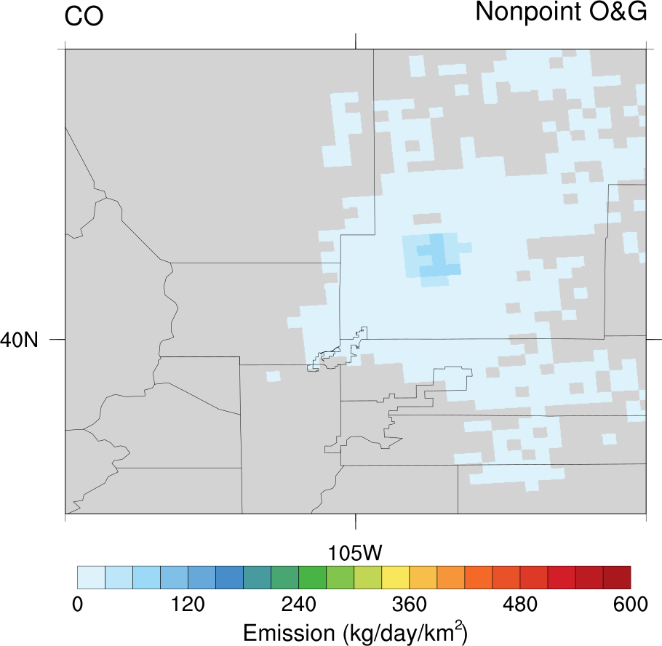
Onroad mobile: 508.05 Ton/day | Nonroad mobile: 439.25 Ton/day | Biogenic: 85.50 Ton/day | Nonpoint O&G:: 41.67 Ton/day

! Model seems to overestimate the amount of horizontal transport over the area of SE of Denver.
! CO : Onroad & Nonroad mobile emission -> 20% up

Ethane
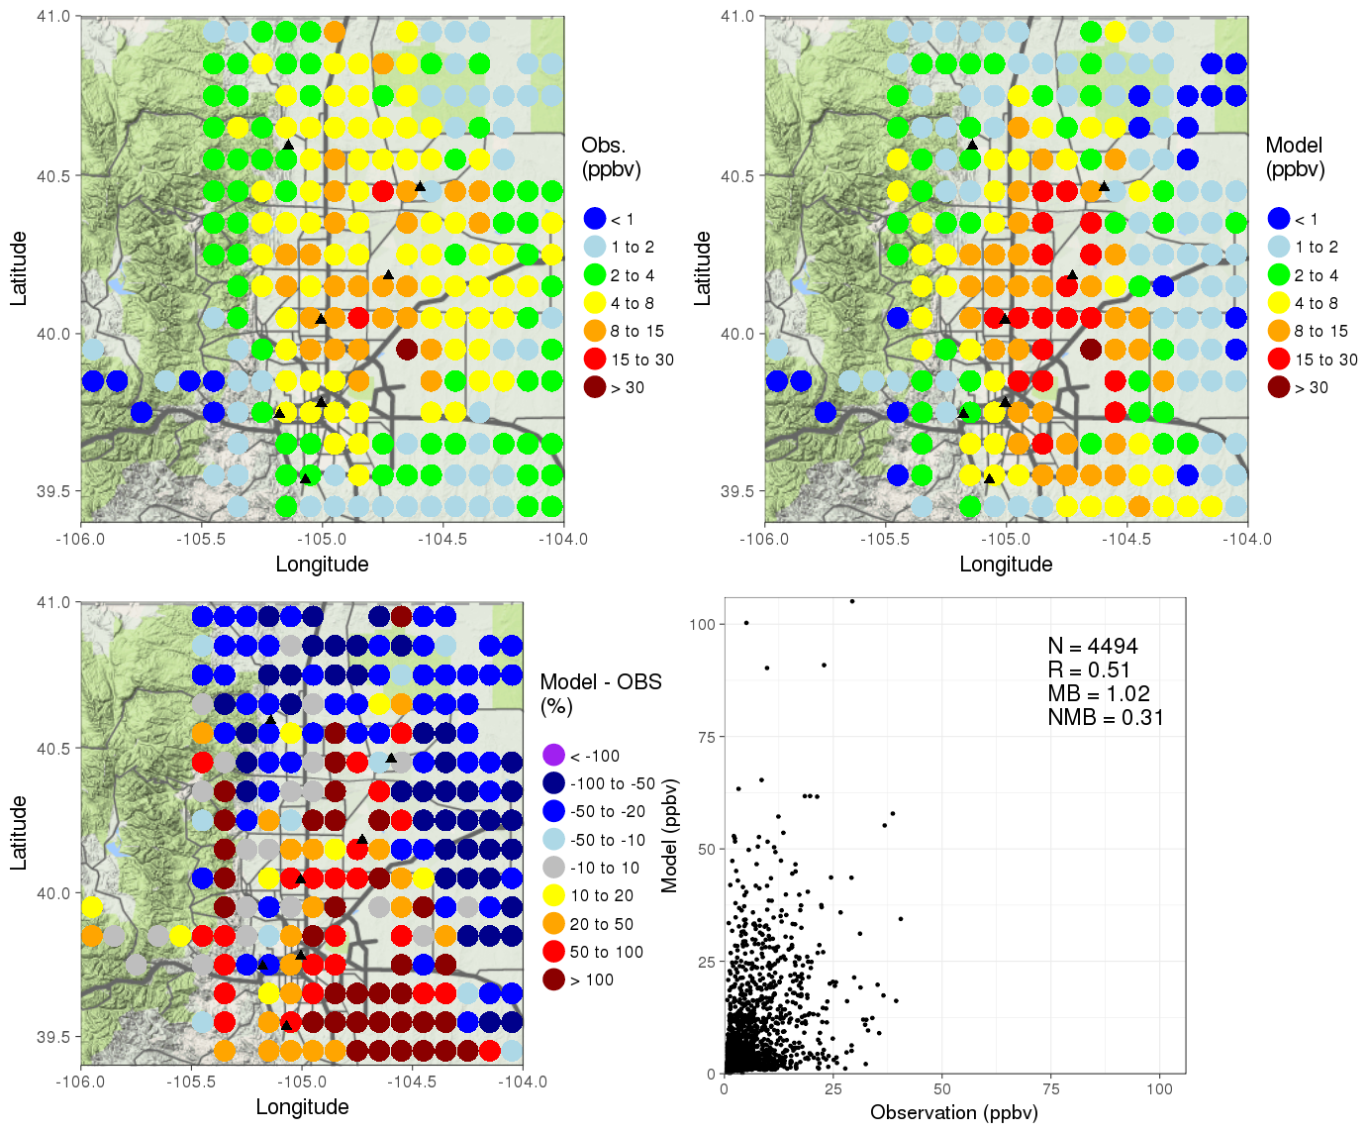
The largest 4 sector emissions of ethane in the Front range

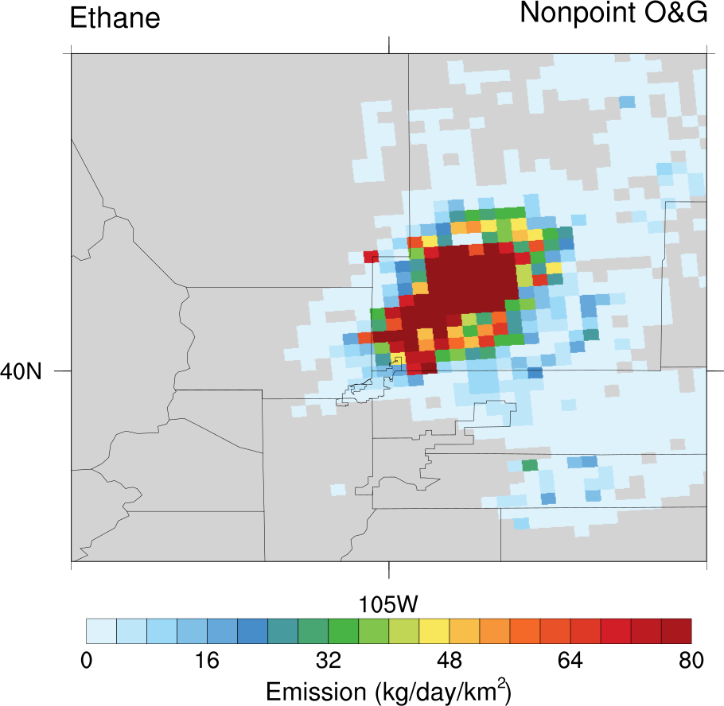 | 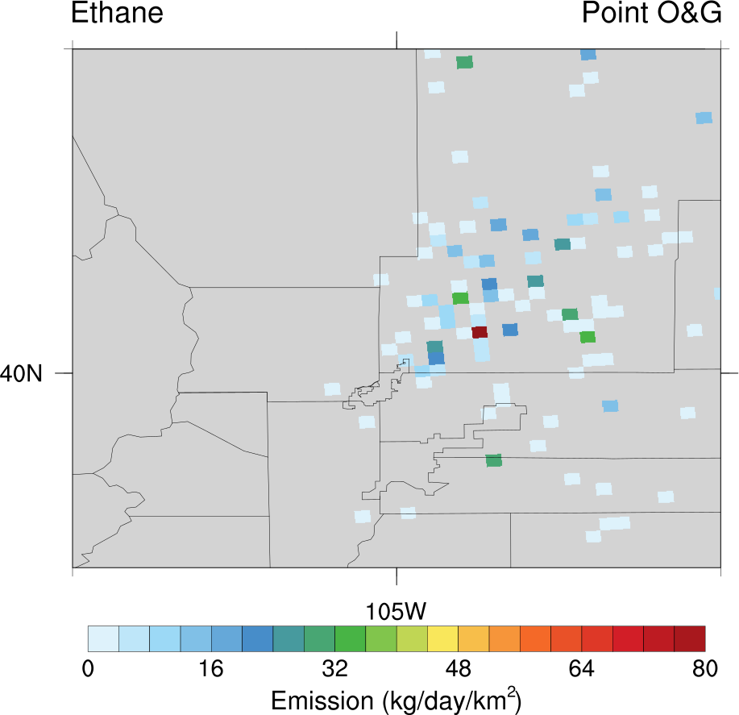 | 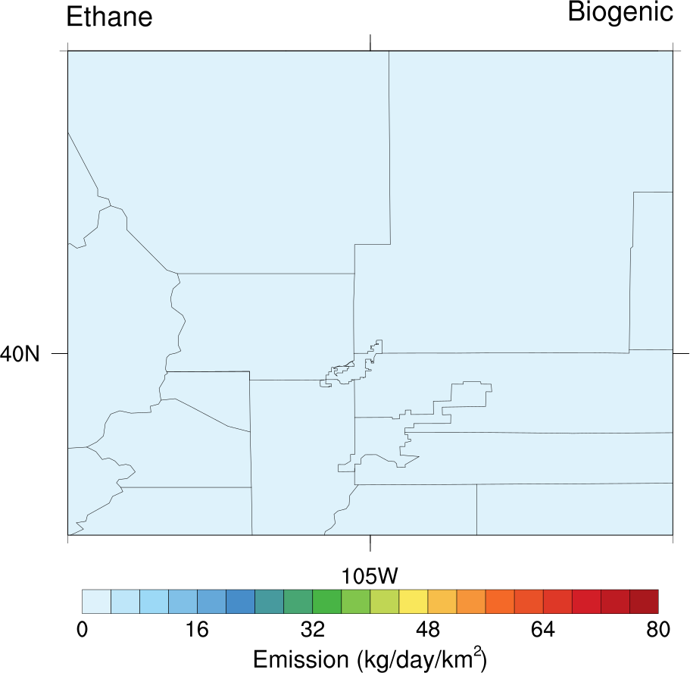 | 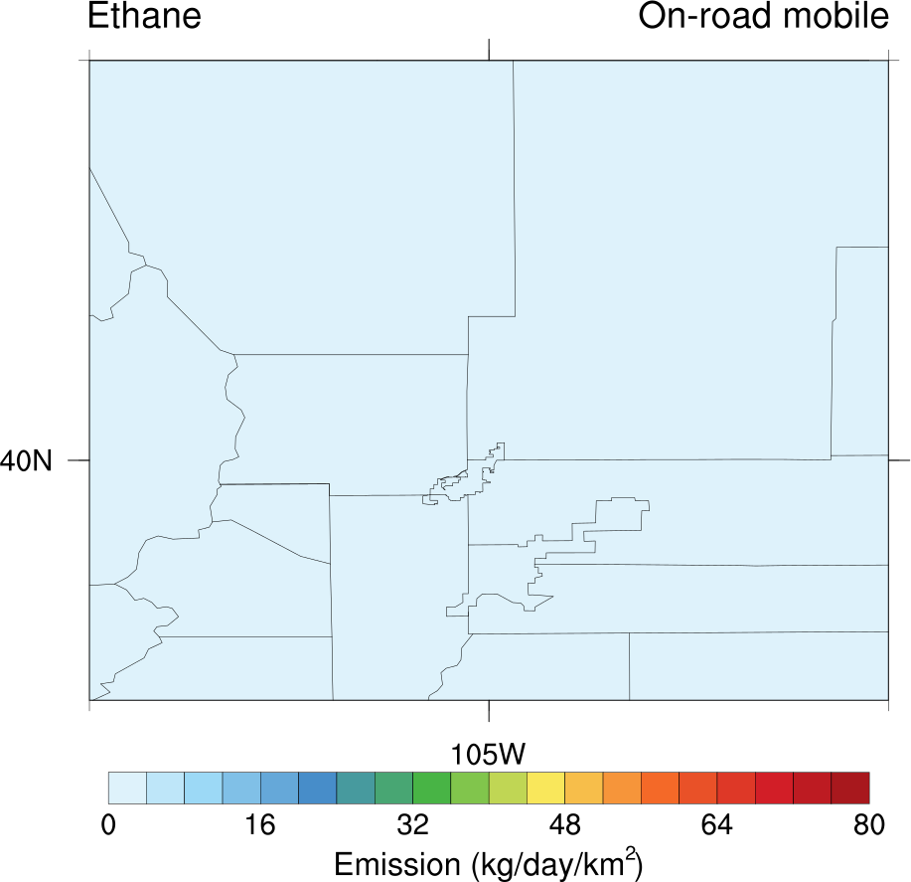
Nonpoint O&G: 223.90 Ton/day | Point O&G: 11.42 Ton/day | Biogenic:: 3.05 Ton/day | Onraod mobile:: 0.75 Ton/day

! Model overestimate the level of ethane over the nonpoint O&G emission area, but underestimate the level over the eastern of the O&G emission area.
! Ehane: nonpoint O&G emission-> 30% down씨

Benzene
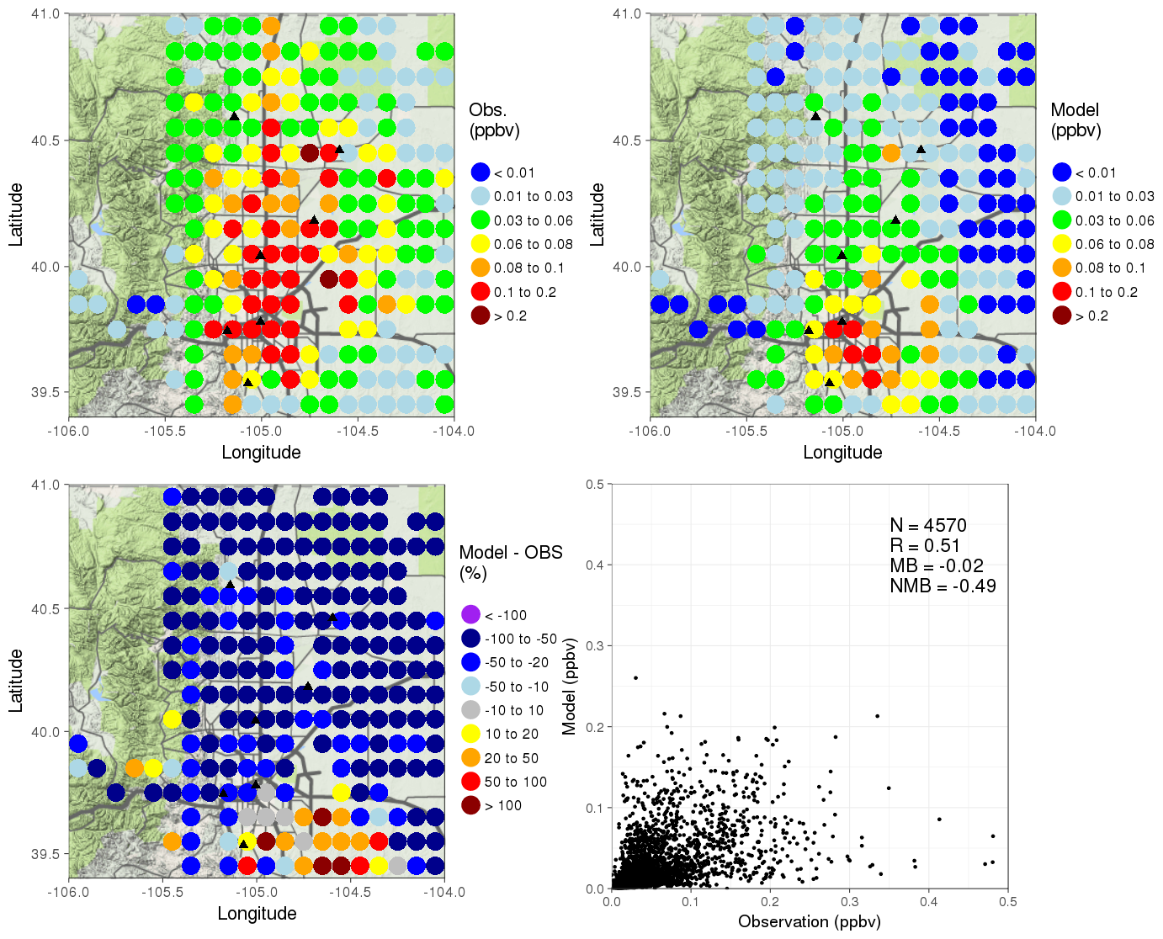
The largest 4 sector emissions of benzene in the Front range

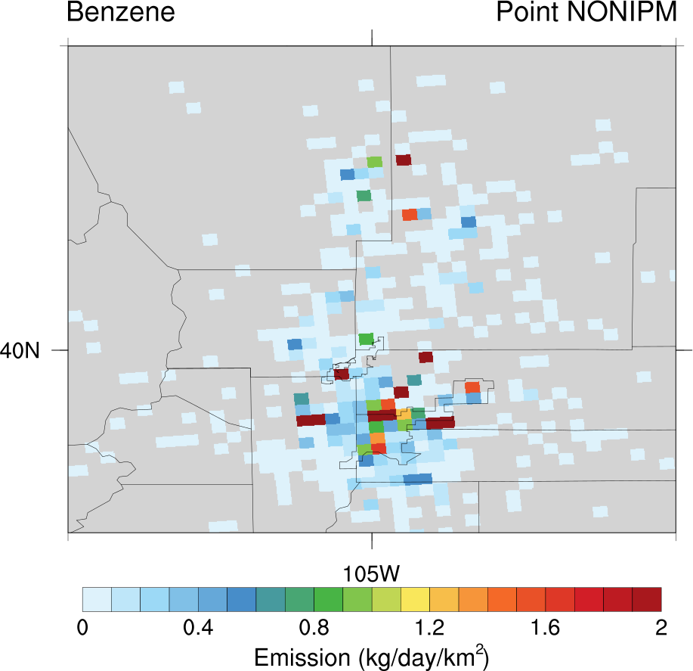 | 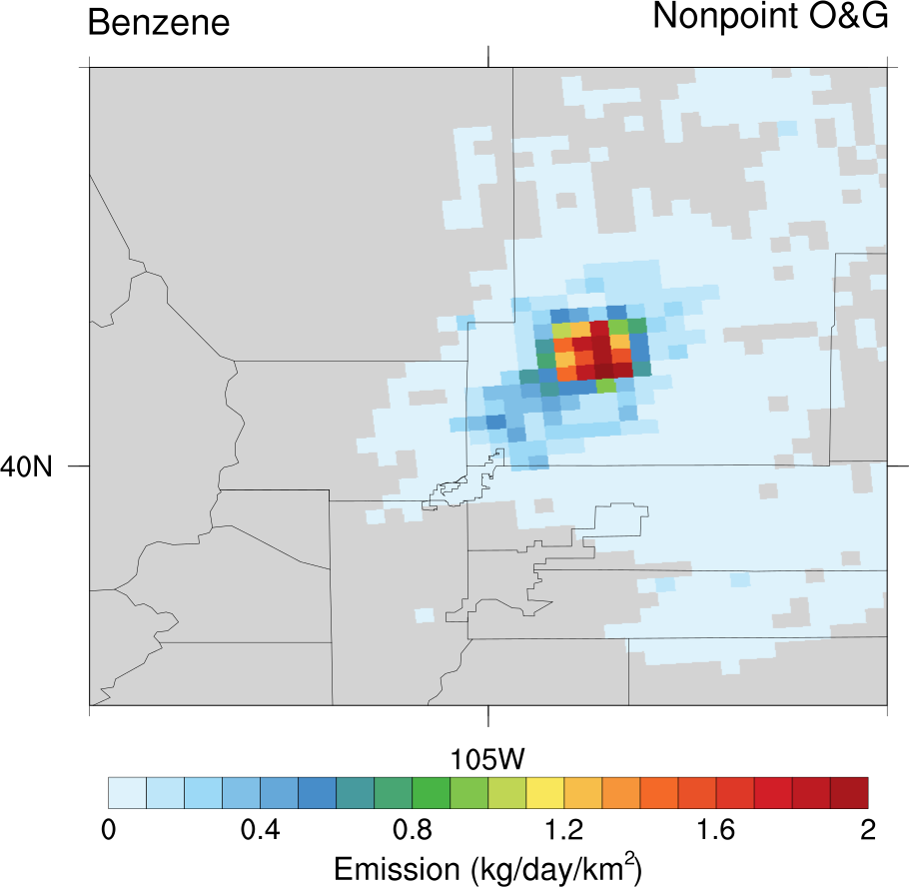 | 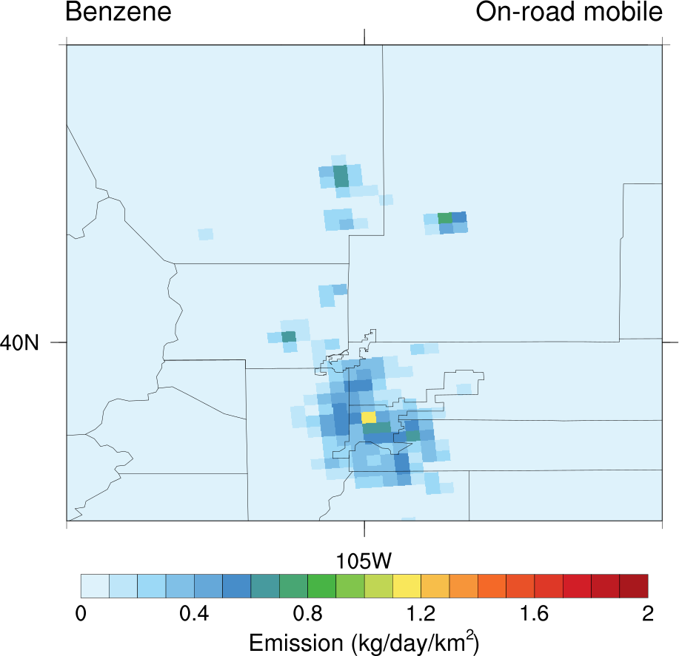 | 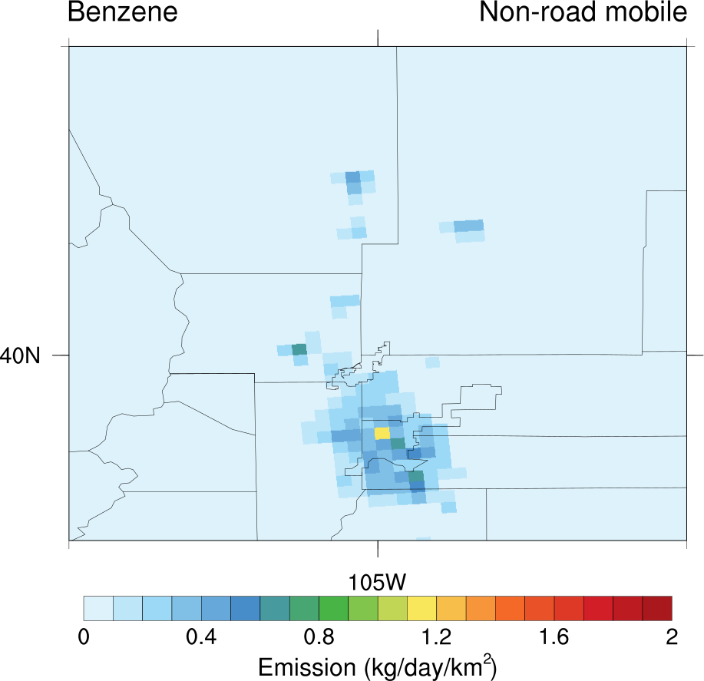
Point NONIPM: 1.21 Ton/day | Nonpoint O&G: 0.95 Ton/day | Onroad mobile: 0.71 Ton/day | Nonroad mobile: 0.71 Ton/day

! Benzene: all emission source except biogenic -> 50% up

Toluene
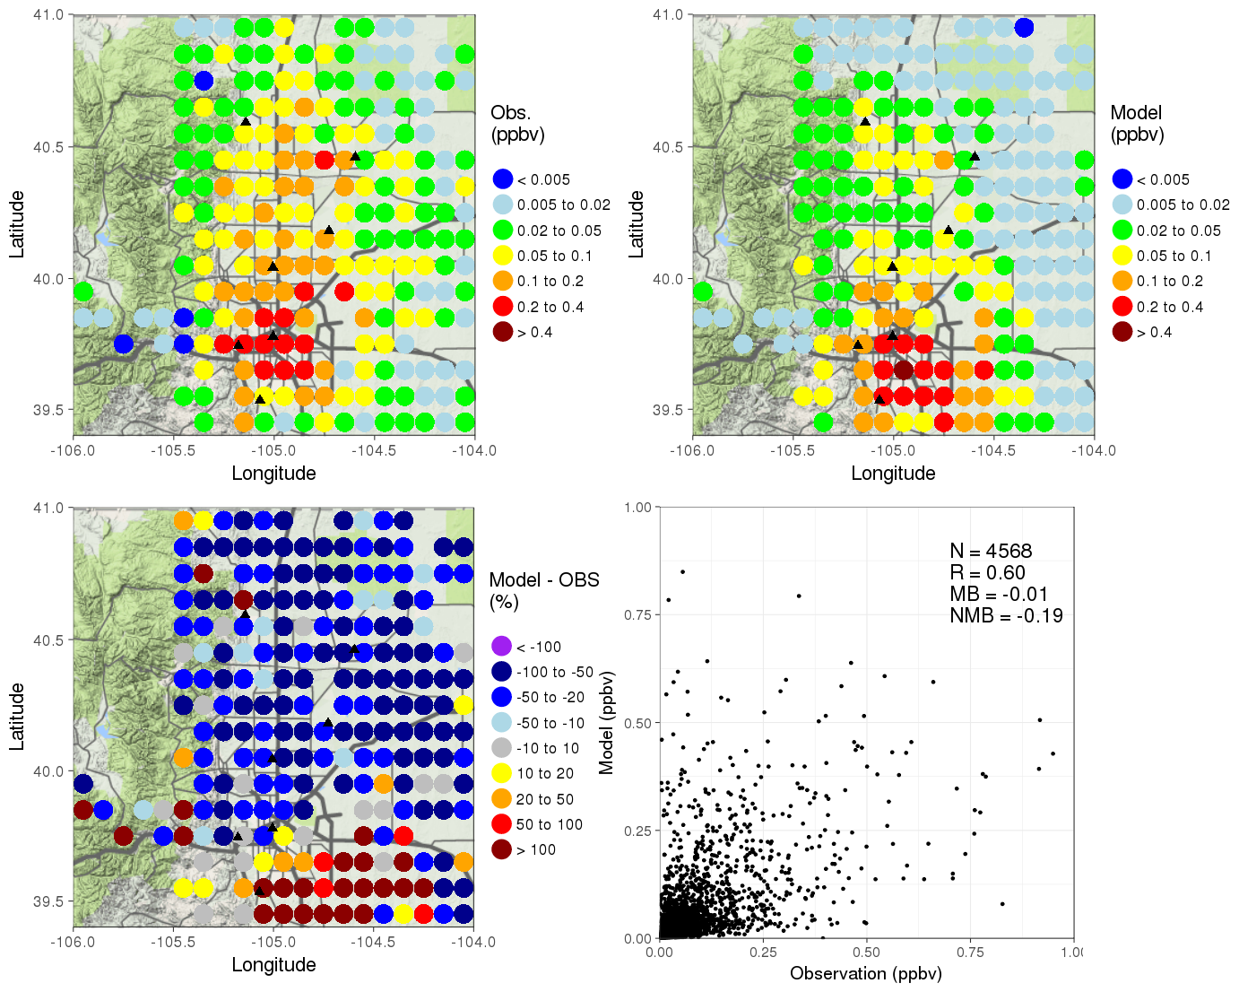
The largest 4 sector emissions of toluene in the Front range

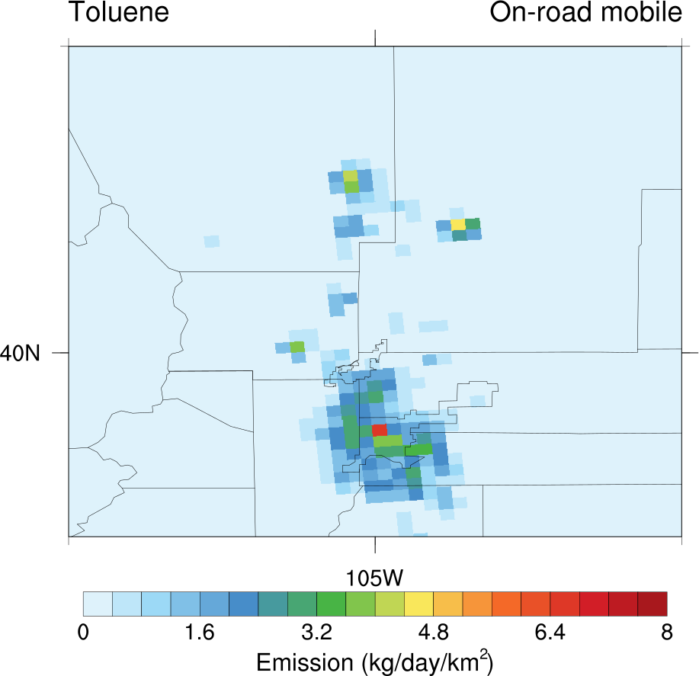 | 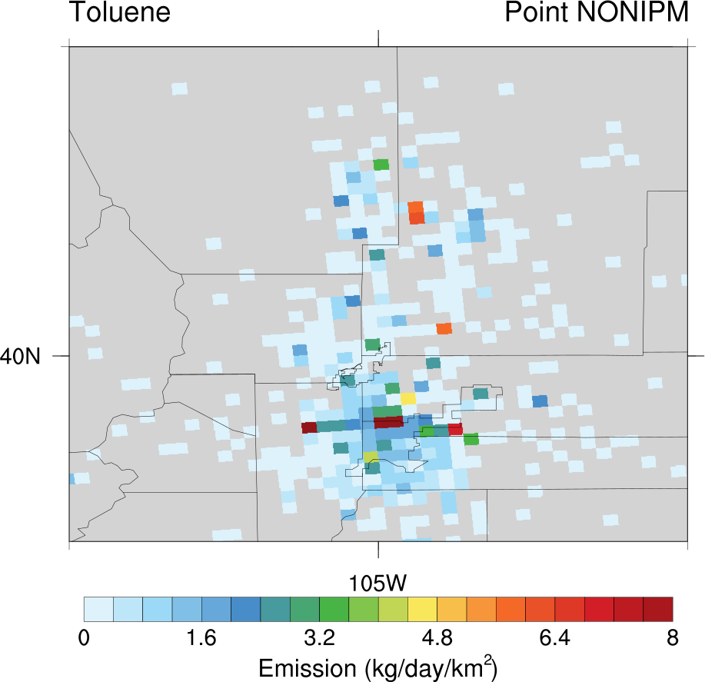 | 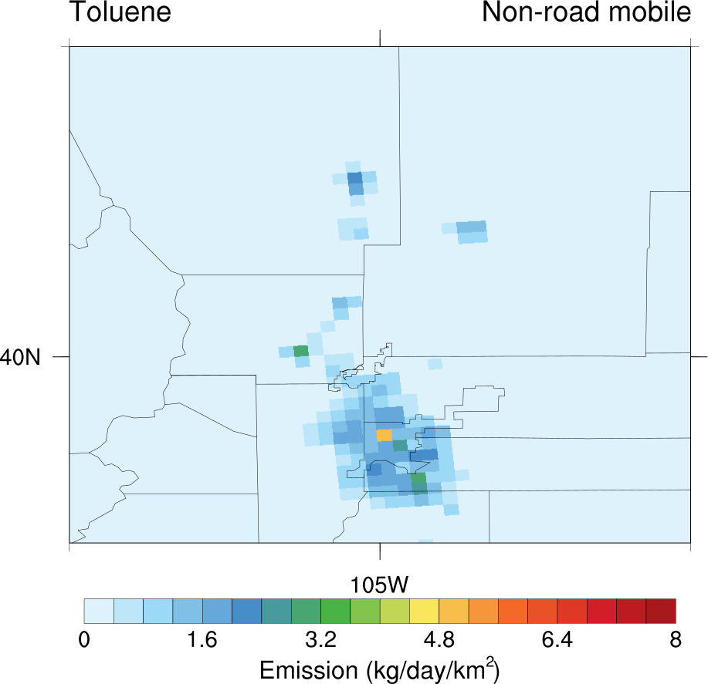 | 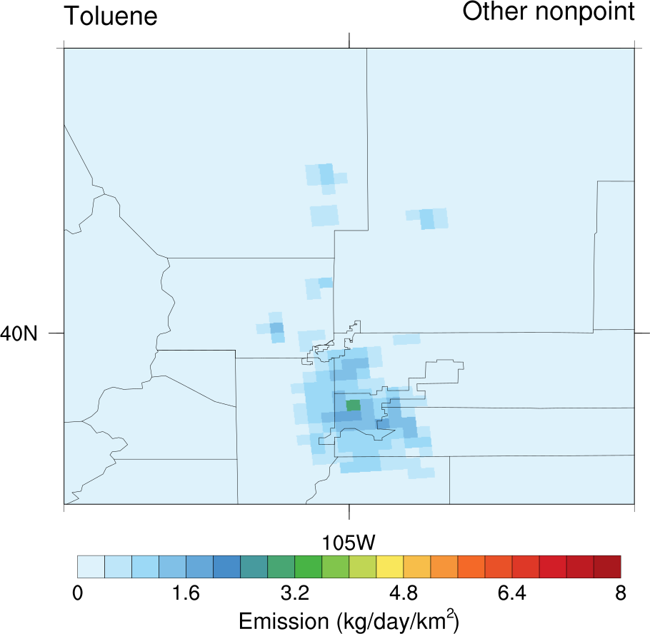
Onroad mobile: 4.83 Ton/day | Point NONIPM: 3.87 Ton/day | Nonroad mobile: 3.48 Ton/day | Other nonpoint: 2.37 Ton/day

! Toluene: all emission source except biogenic -> 20% up

Ketone
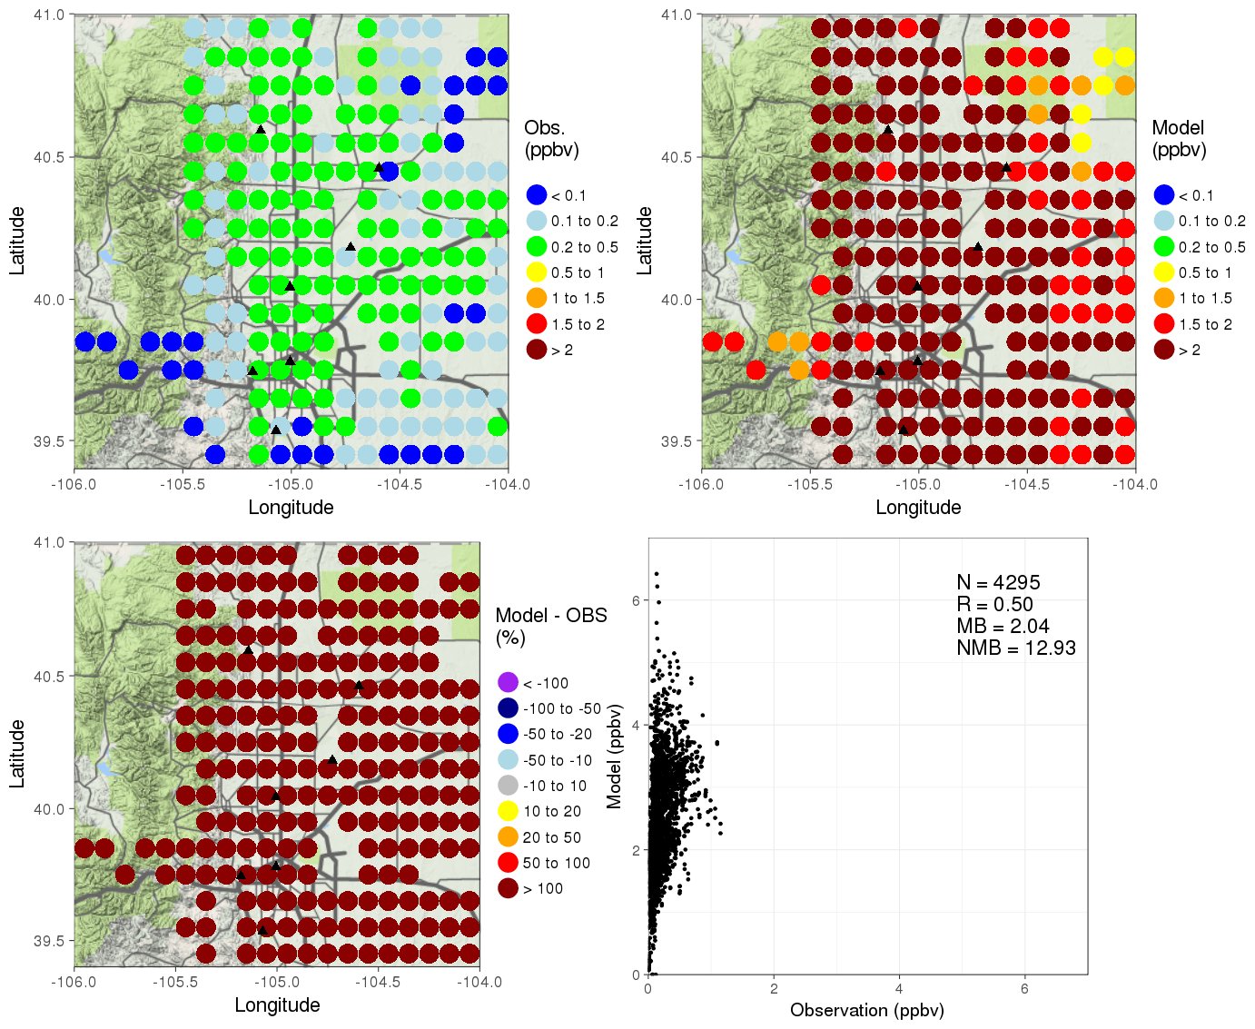
The largest 4 sector emissions of ketone in the Front range

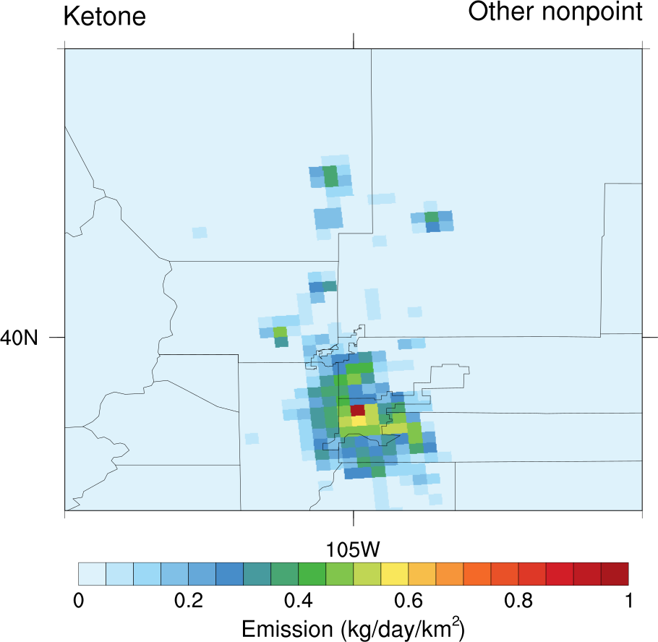 | 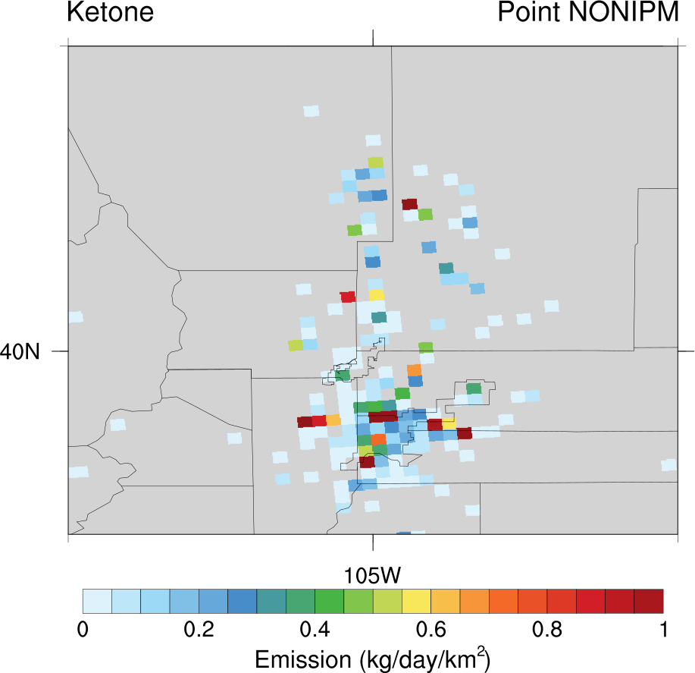 | 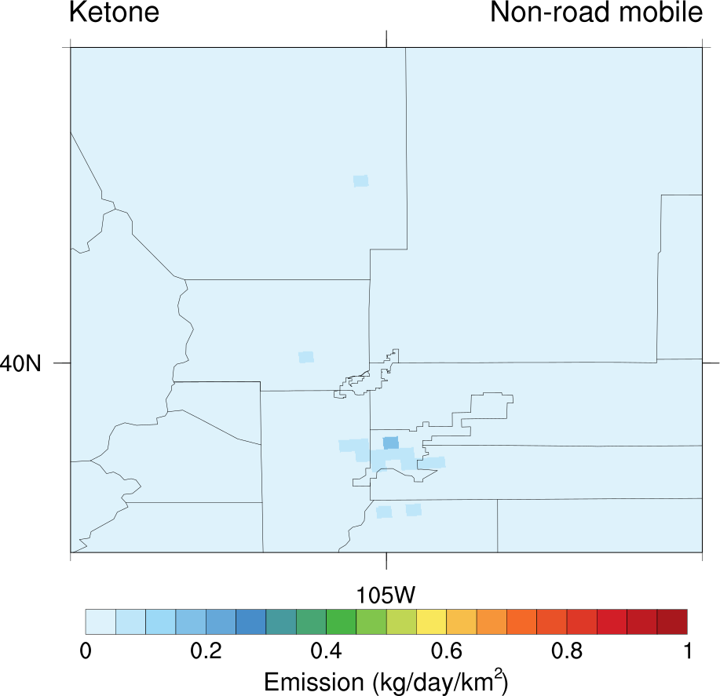 | 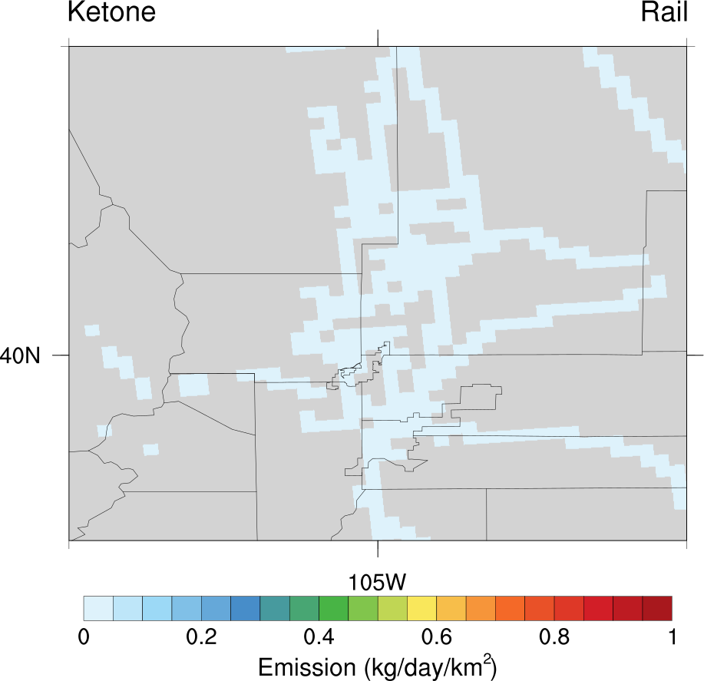
Nonpoint other: 0.71 Ton/day | Point NONIPM: 0.55 Ton/day | Nonroad mobile: 0.10 Ton/day | Rail: 0.01 Ton/day

! Ketone: all emission source -> 130% down

NTR1 : There is no emission source.
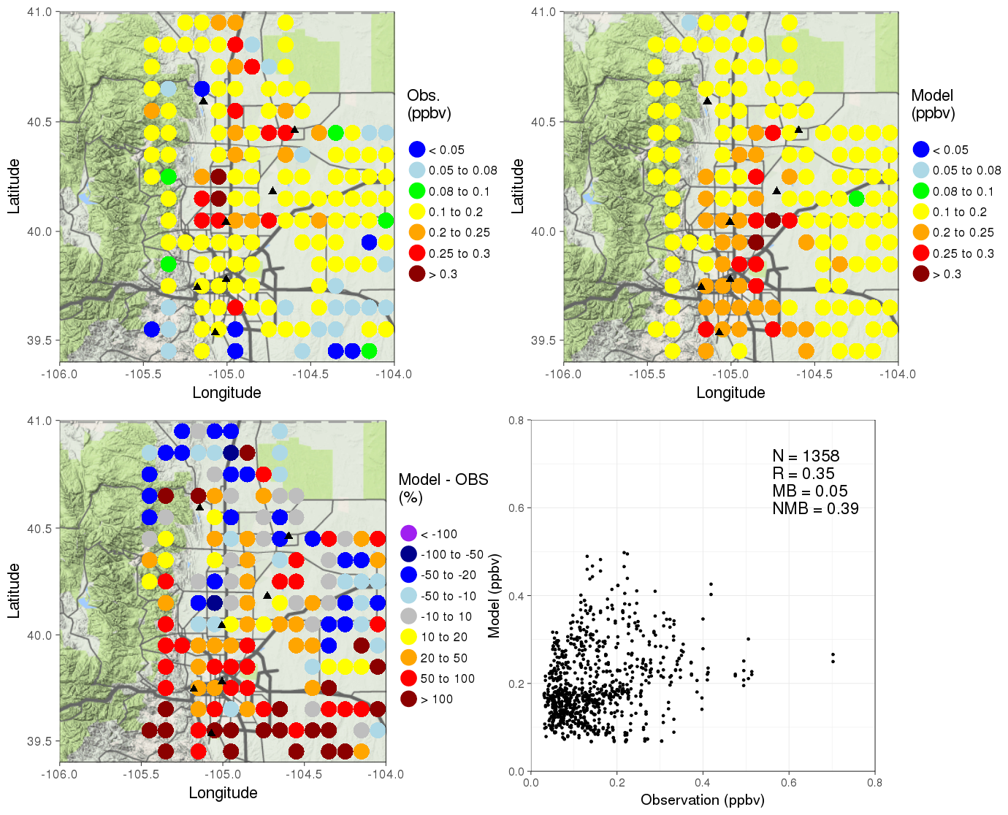

PAR
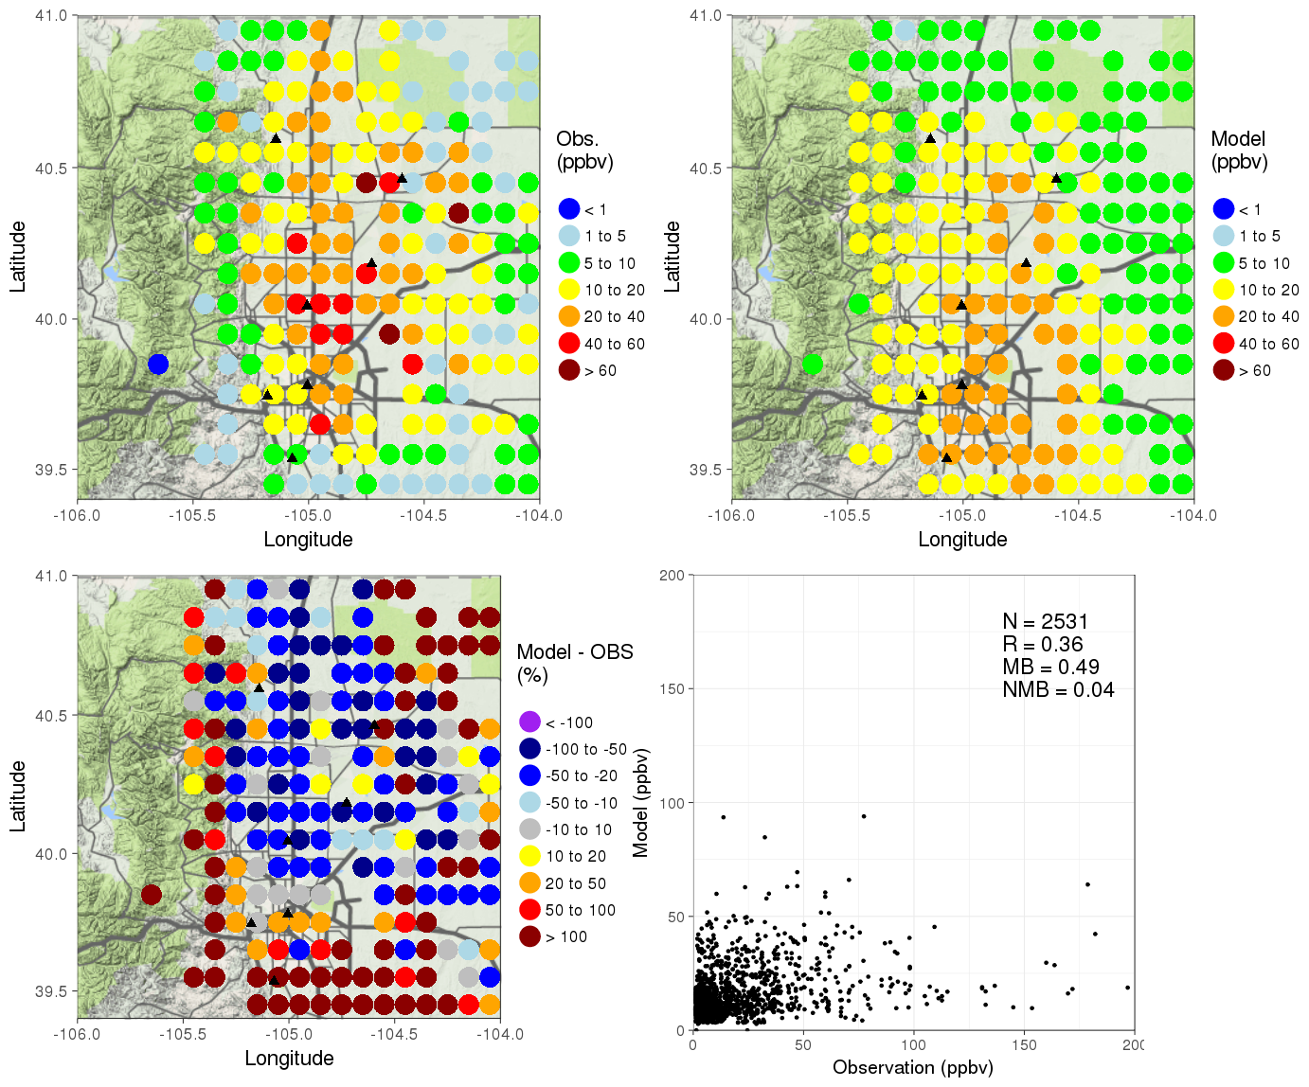
The largest 4 sector emissions of PAR in the Front range

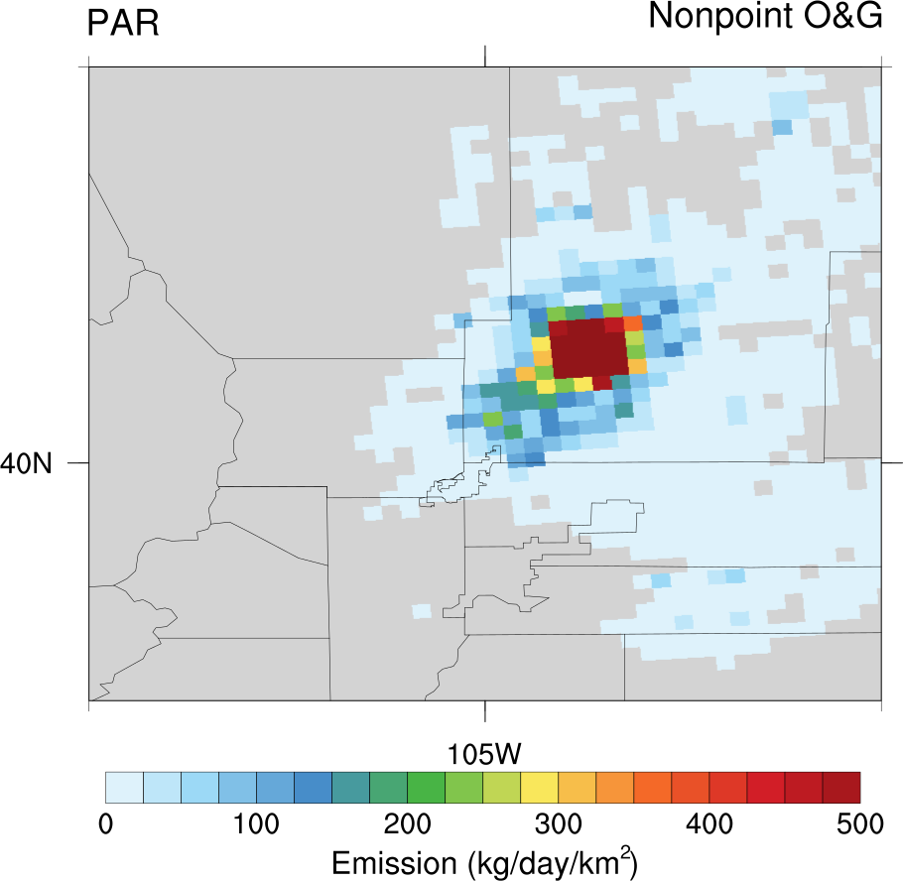 | 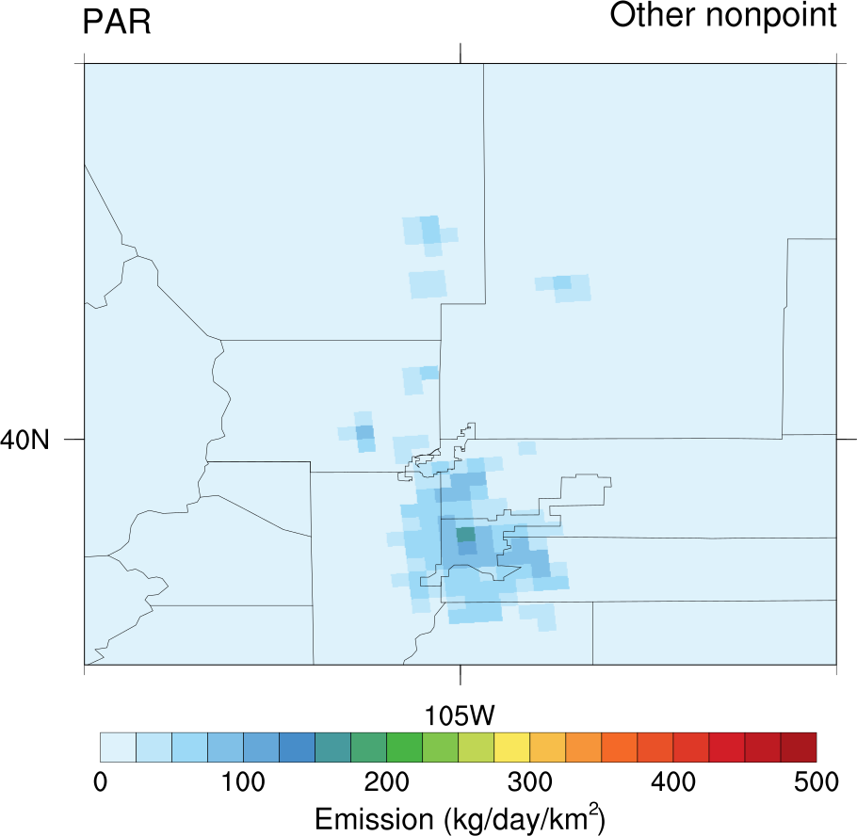 | 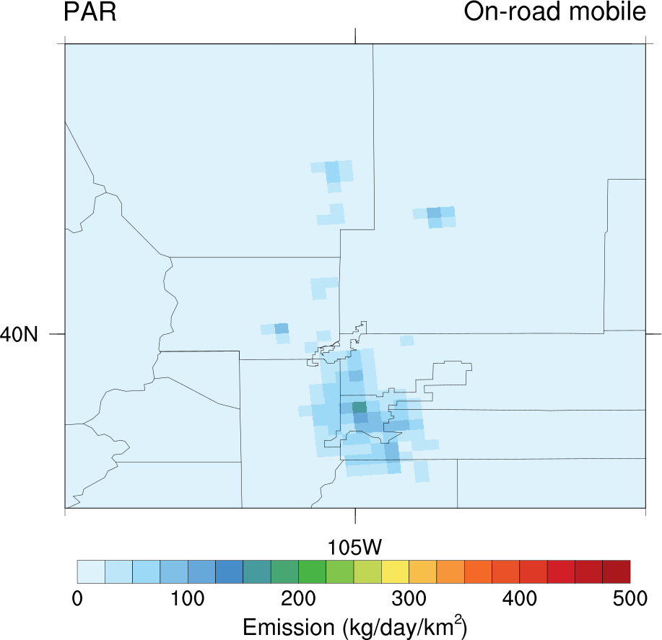 | 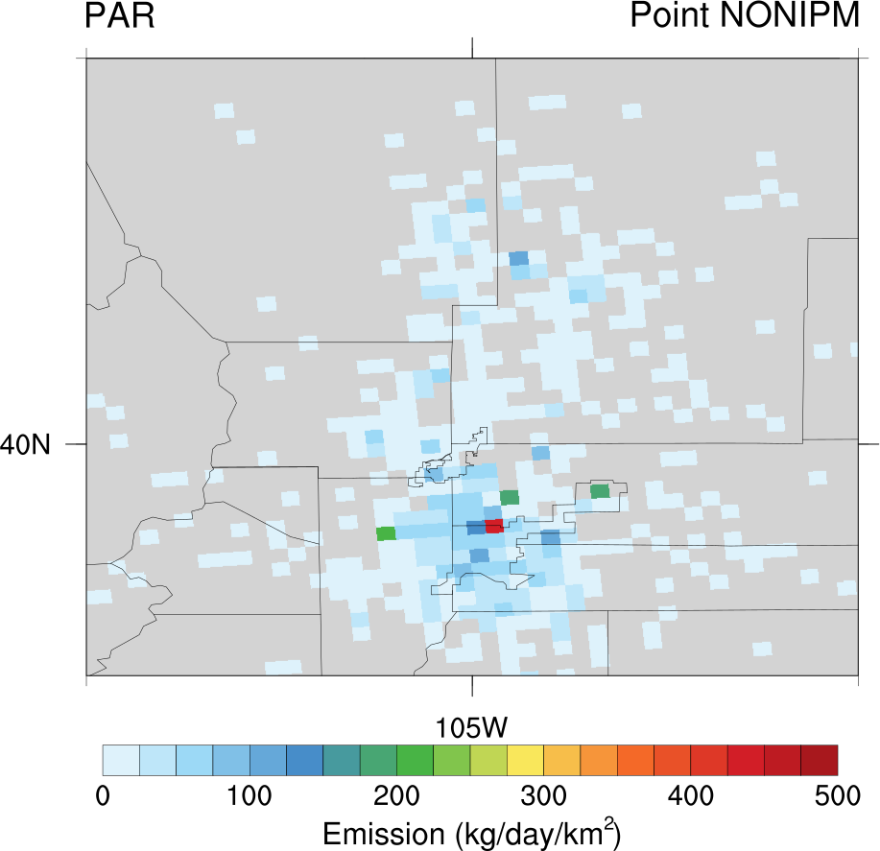
Nonpoint O&G: 443.04 Ton/day | Nonpoint other: 132.52 Ton/day | Onroad mobile: 116.24 Ton/day | Point NONIPM: 112.05 Ton/day

! PAR :

Ethyne
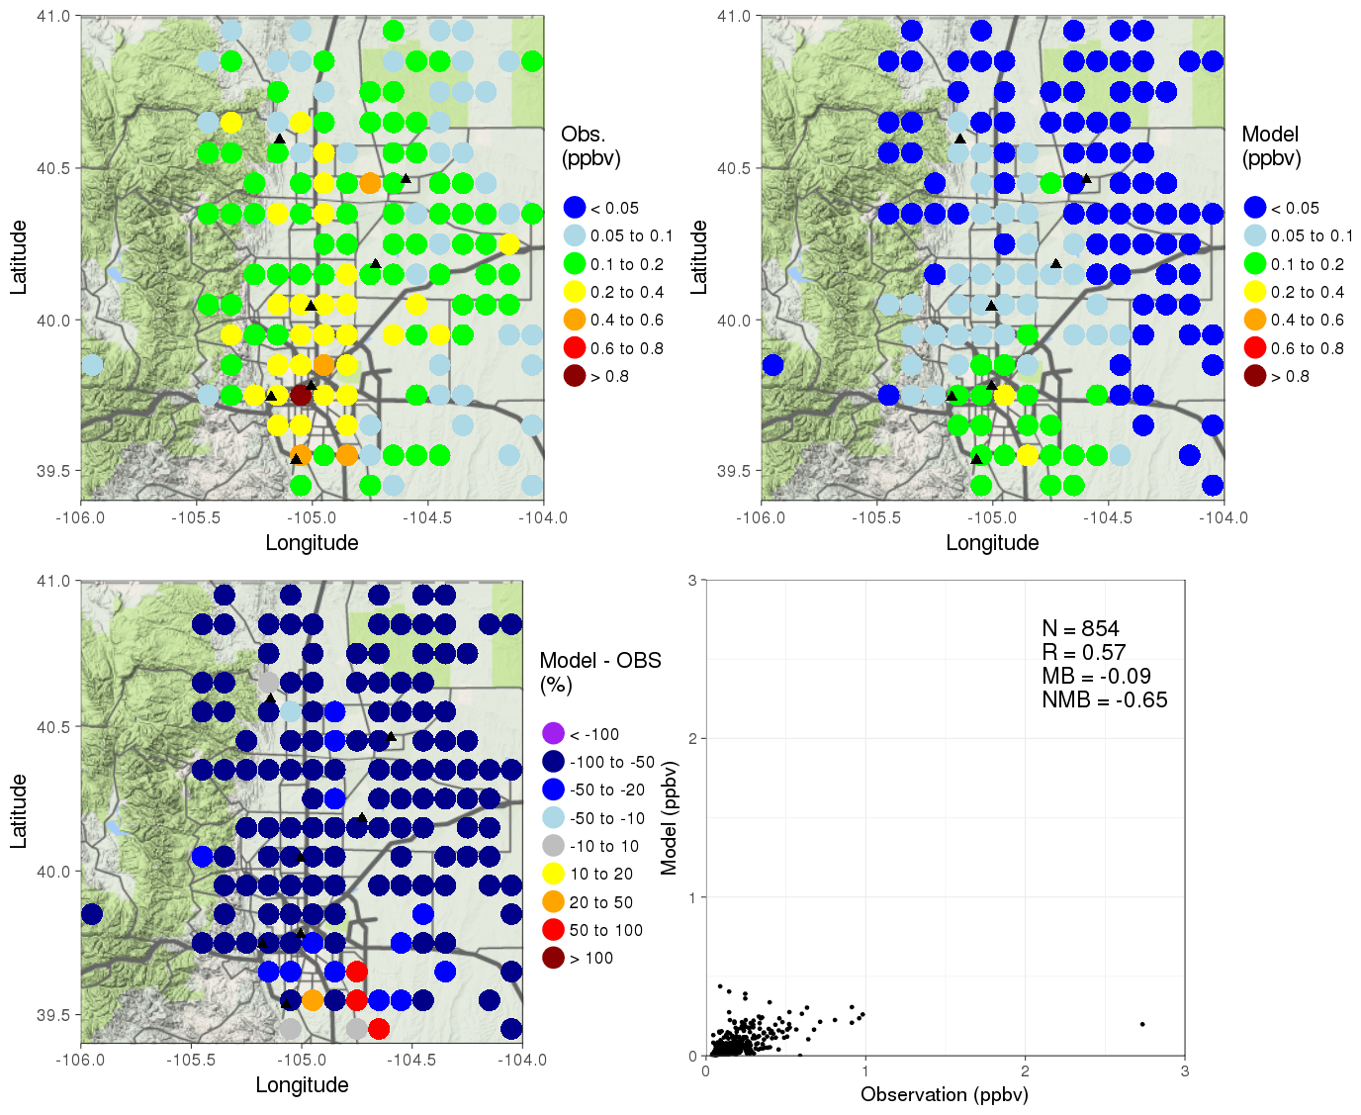
The largest 4 sector emissions of ethyne in the Front range

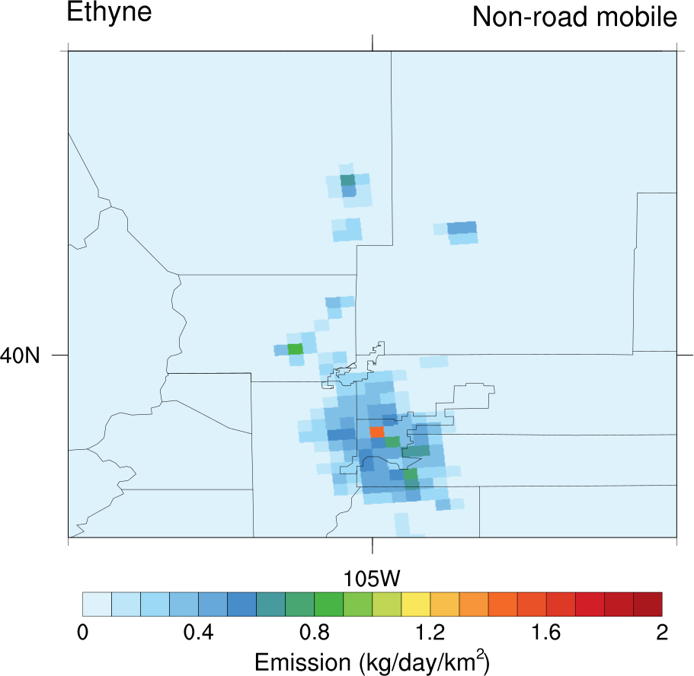 | 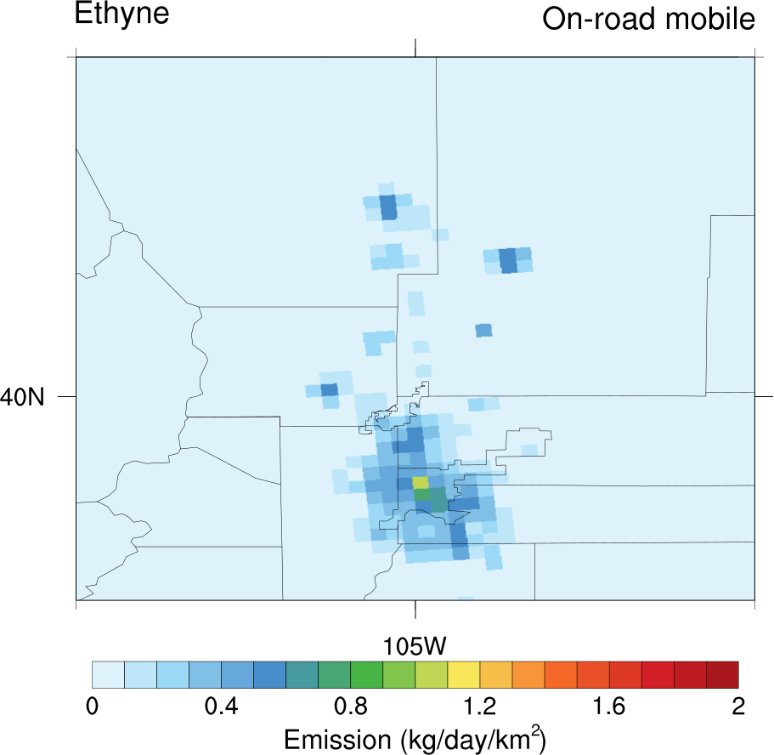 | 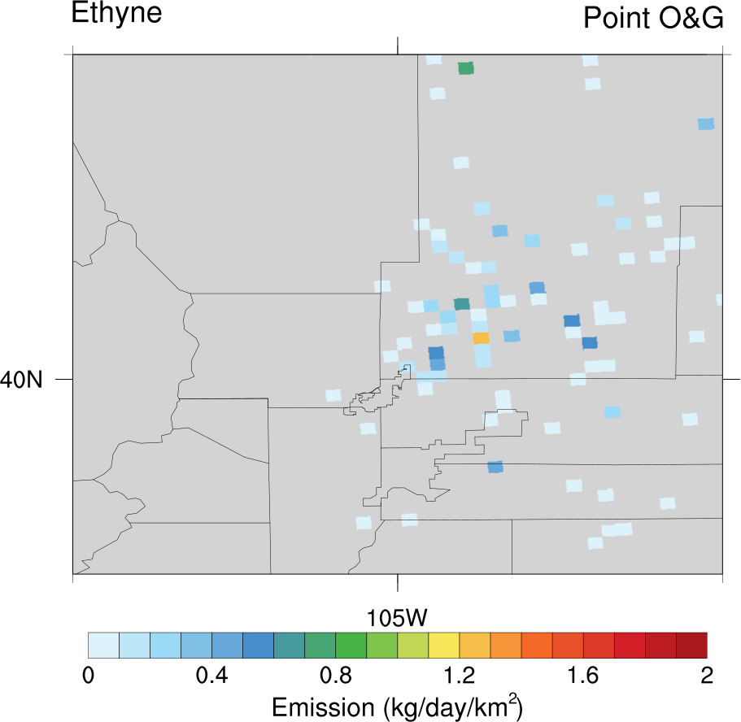 | 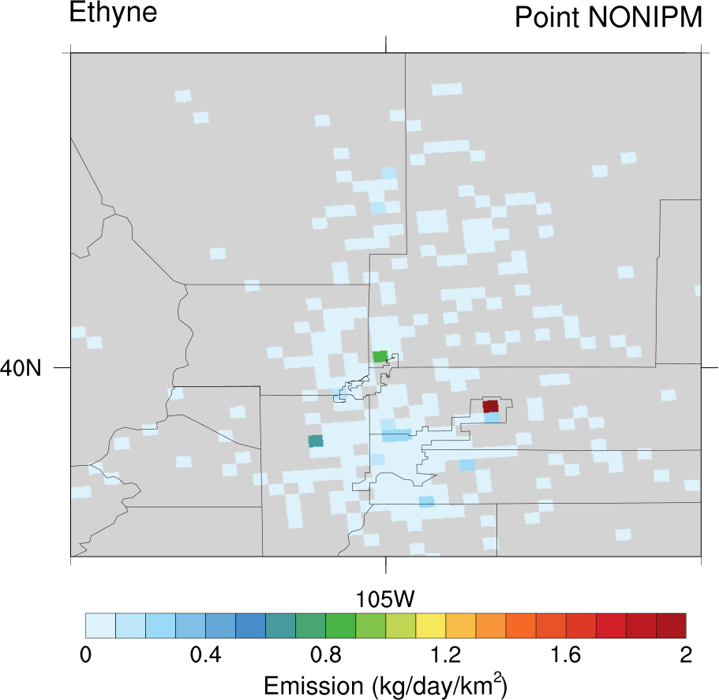
Nonroad mobile: 1.00 Ton/day | Onroad mobile: 0.85 Ton/day | Point O&G: 0.17 Ton/day | Point NONIPM: 0.15 Ton/day

Ethene
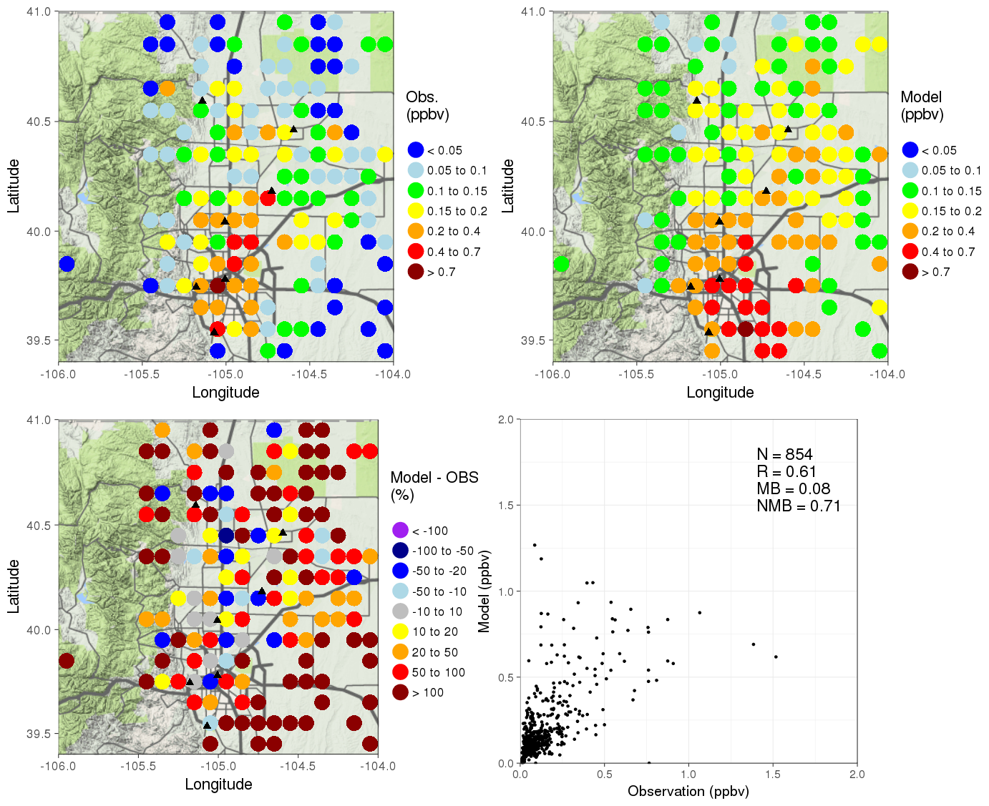
The largest 4 sector emissions of ethene in the Front range

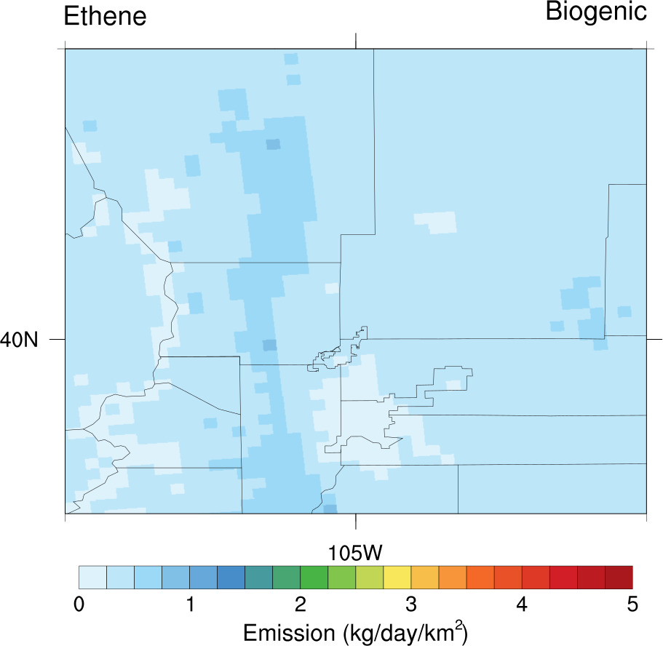 | 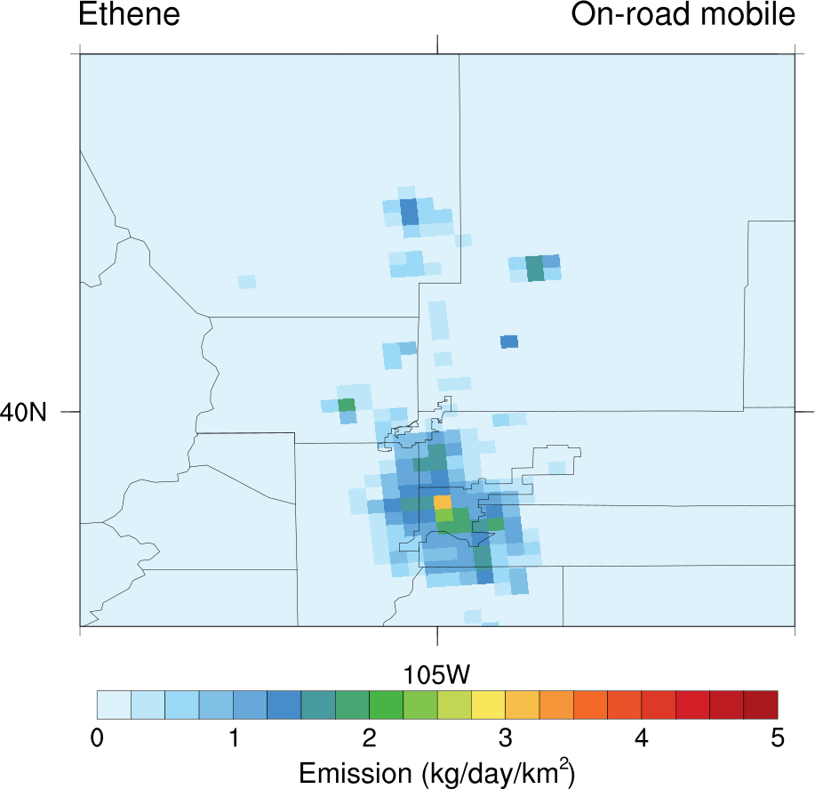 | 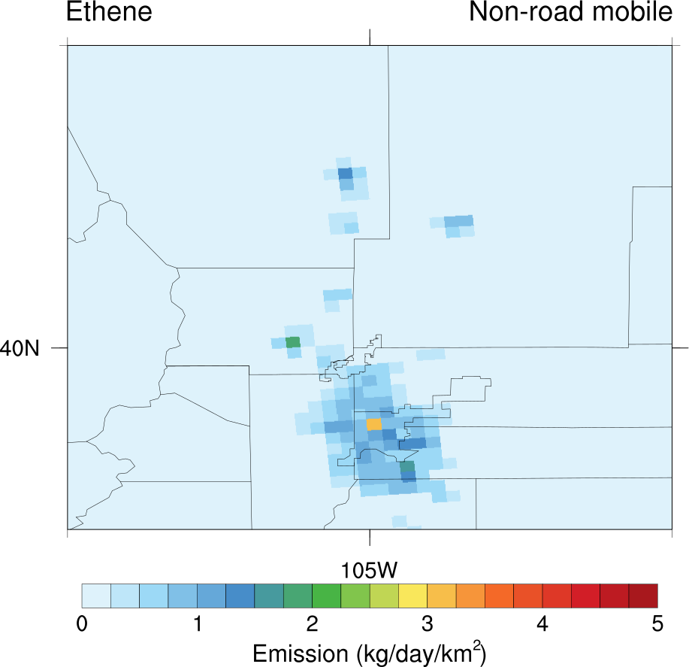 | 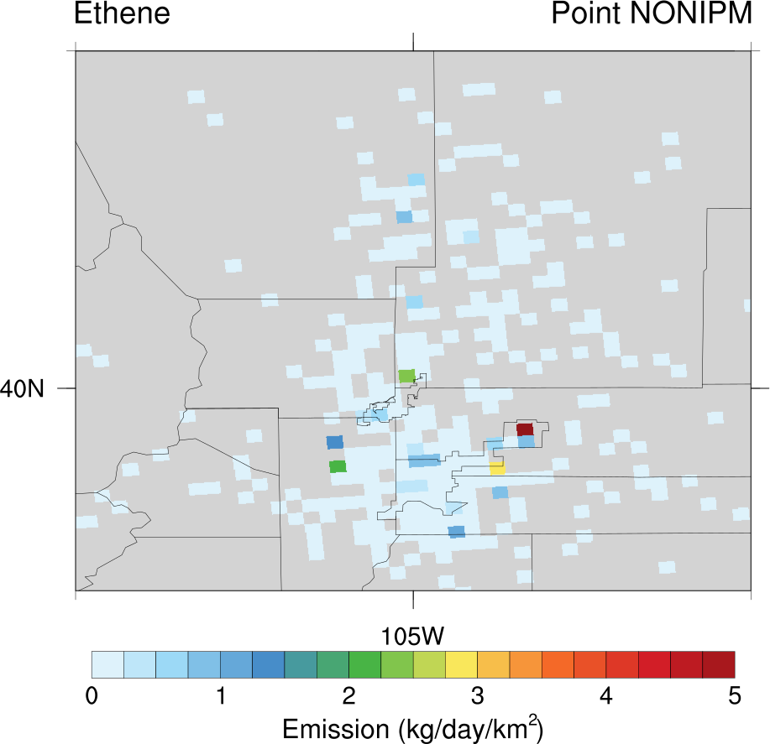
Biogenic: 12.79 Ton/day | Onroad mobile: 2.59 Ton/day | Nonroad mobile: 2.06 Ton/day | Point NONIPM: 0.64 Ton/day

OLE
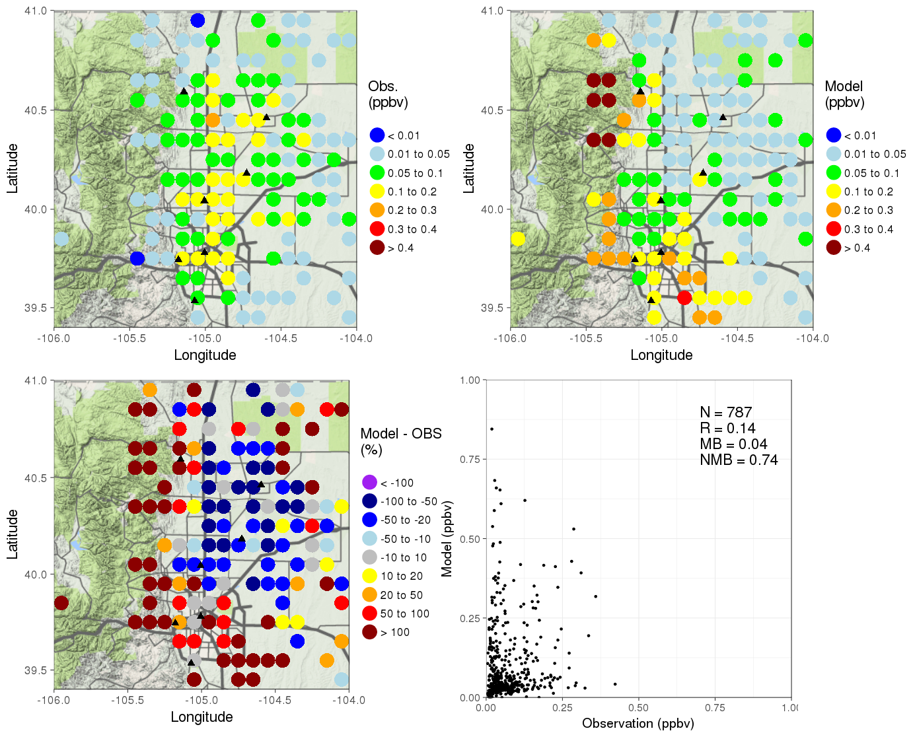
The largest 4 sector emissions of OLE in the Front range

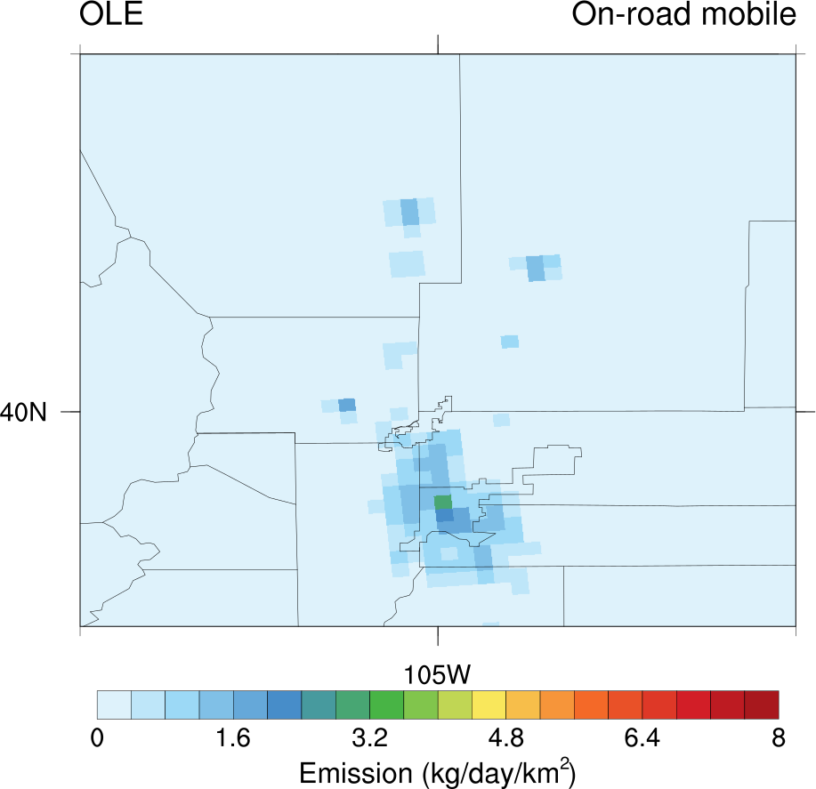 | 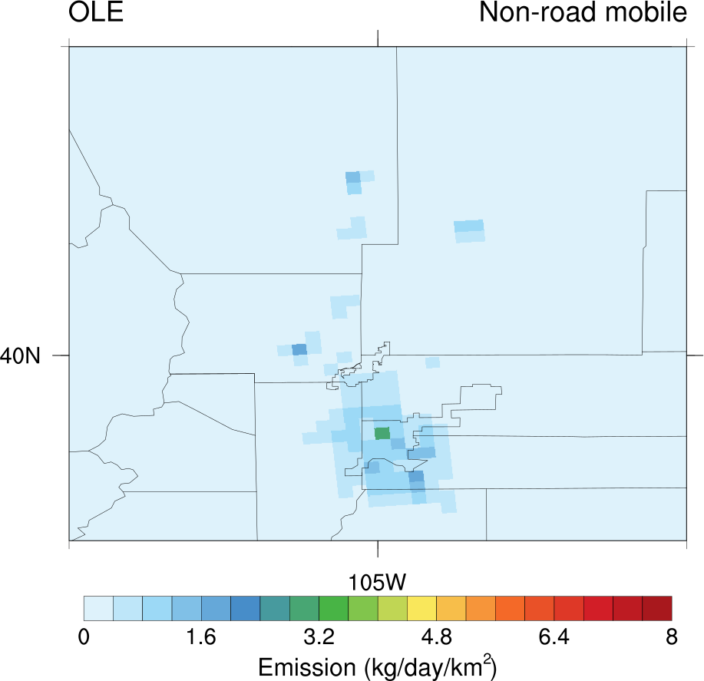 | 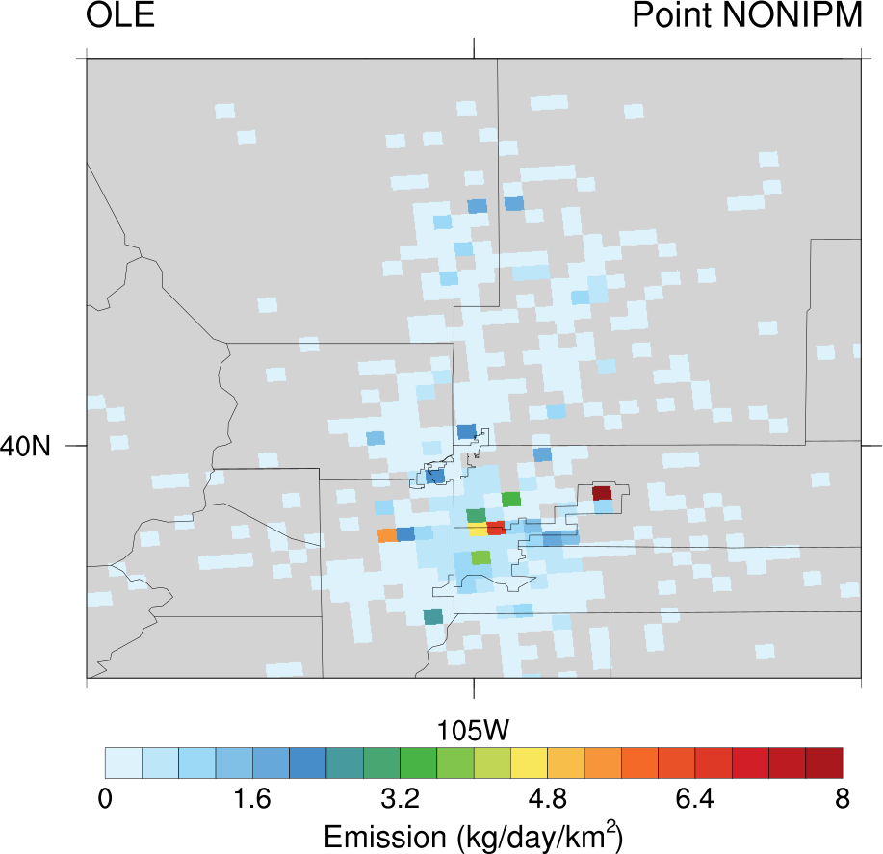 | 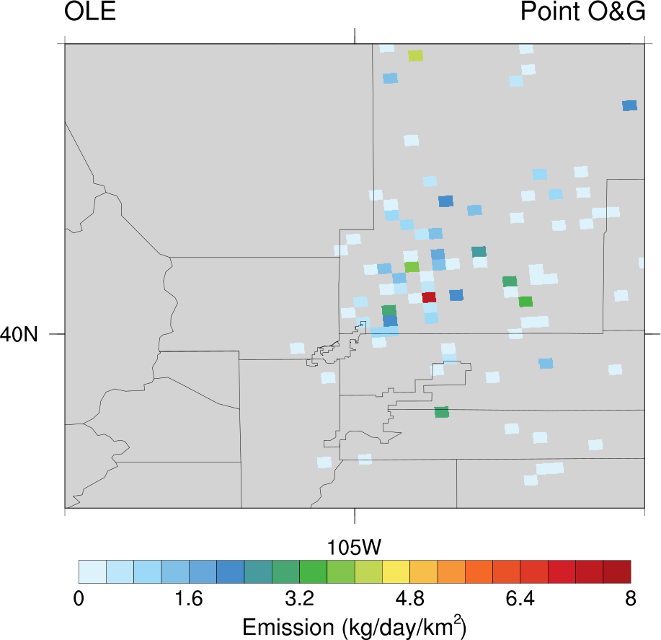
Onroad mobile: 2.33 Ton/day | Nonroad mobile: 2.04 Ton/day | Point NONIPM: 1.88 Ton/day | Point O&G: 1.03 Ton/day

Propane
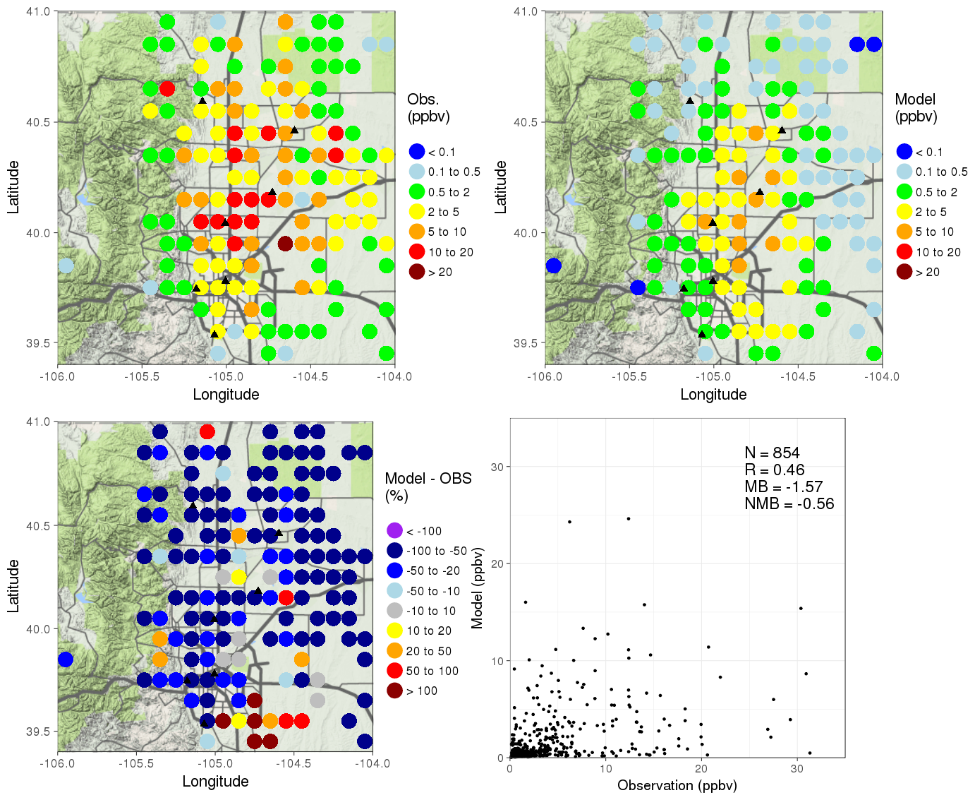
The largest 4 sector emissions of propane in the Front range

Nonpoint O&G: 89.28 Ton/day | Point O&G: 3.81 Ton/day | Nonroad other: 2.01 Ton/day | Onroad mobile:: 0.13 Ton/day

