Sleuthing FTS-MOPPIT inconsistencies - Method

Events were located by identifying peaks outside the seasonal variation envelope in the anomalies graphs (see events a-z in figure, produced by David Edwards). FTS daily averaged retrievals were separated into seasons Summer- DJF, Autumn -MAM, Winter – JJA, Spring – SON and ten year seasonal means calculated. Subsequently, several days of unusually high total column retrieval within event dates were flagged in the FTS data, as indicated by daily averages lying greater than one standard deviation (12.85% of data) away from the seasonal mean. Extremely unusual, or atypical, data was defined as those daily total columns located greater than one and a half standard deviations (6.96% of data) from the seasonal mean.

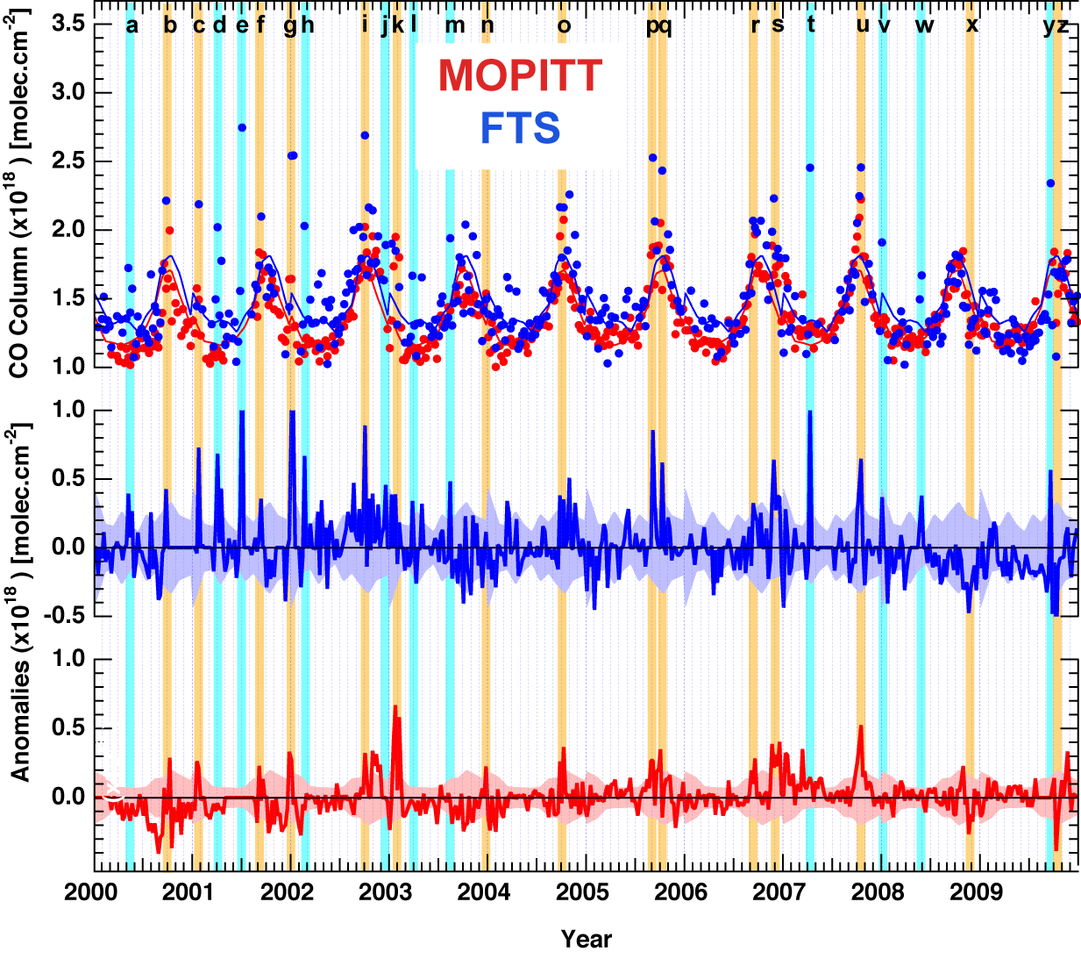
Five event types were defined. First (I), events were noted in which both MOPITT and FTS observed approximately the same magnitude in the total column values and anomaly plots. Second (II), events were observed by both MOPITT and FTS, with the FTS anomaly plot showing a substantially higher anomaly signal. Third (III), events which were observed by FTS and MOPITT, with MOPITT anomaly plot indicating a greater anomalous event than the FTS. Fourth (IV), events were found in which only the FTS retrieved anomalous column data. Finally (V), events with particularly low anomalies were identified. Grouping of events into event types is displayed in the table below, along with hypothesised general causes for event type characteristics.

Event type | FTS | MOPITT | Events | Reason for event type characteristics
I | y | y | b, f, o, r, s, u | Differences in total column scales between instruments in these cases is likely to be caused by lower spatial resolution of the satellite - “smearing” data due to ground pixel resolution (22x22km [1]) and the altitude limit of MOPITT (approx. 700 hPa). MOPITT is very good at viewing CO at 500 hPa [1].
II | y  high  anomaly | y  low anomaly | c, g, i, p, q | Spatial smearing alone is not adequate to describe instrument differences. Anomaly in both instrument retrievals suggests a long range CO plume detected by both. However, substantial differences indicate additional local sources may be contributing to the total column retrieved by the FTS, but not MOPITT.
III | y  low anomaly | y  high  anomaly | k, n | MOPITT spatial resolution smearing of long range high altitude fire plume.
IV | y |  | a, d, e?, h, j, l, m, t, v, w, y | Likely due to local enhancement such as local pollution (held in the region by an inversion layer), low altitude bushfire plume or Sydney pollution plumes, which all may be retrieved by the FTS, but are difficult for MOPITT due to the satellite instrument's altitude limit (approx. 700 hPa).
V | y  neg  anomaly | y  neg  anomaly | x, z | Transport of lower concentrations of CO from lower latitudes.

Once events of interest were located and culprit total columns flagged, several avenues of investigation followed:
  - FTS daily records were searched to see if there was anything noted by the FTS operator.
  - MODIS fire location data were determined using the FIRMS web fire mapper (http://firefly.geog.umd.edu/firemap/) around the dates of interest. If a fire was located in the region, maps were determined from beginning to end of fire.
  - The Rural Fire Service (RFS) was contacted to find biomass burning events in the area. Maree Larkin phoned 6/12 and said they will go through maps – get back to me end of next week. Visited Michael Gray on 10/01/2011: Discussed that 2001/2002 Christmas Sydney fires burnt everything in the Illawarra zone and there is a 7-8 year waiting period before they can burn again by Hazard Reduction. There was a small area left near Tarrawanna unburnt, however the RFS left this unburnt till 2010, to be a safe haven for wildlife.
  - Back trajectories were run using the BADC web trajectory service (http://badc.nerc.ac.uk/) for the days of particularly high concentration. (GPS location of Wollongong: -34.406, 150.879). Five day backwards trajectories were initially run from 18:00, with output frequencies of 1 hour and at Levels 950, 750 and 450 hPa (approx. 0.5, 2.6 and 5.7 km respectively). Forward trajectories were run for selected days from locations suspected to contribute to total column measurements.
  - Wind data from Albion Park, Bellambi and UOW sites during events of interest was obtained from the Bureau of Meteorology (6/12/2010)
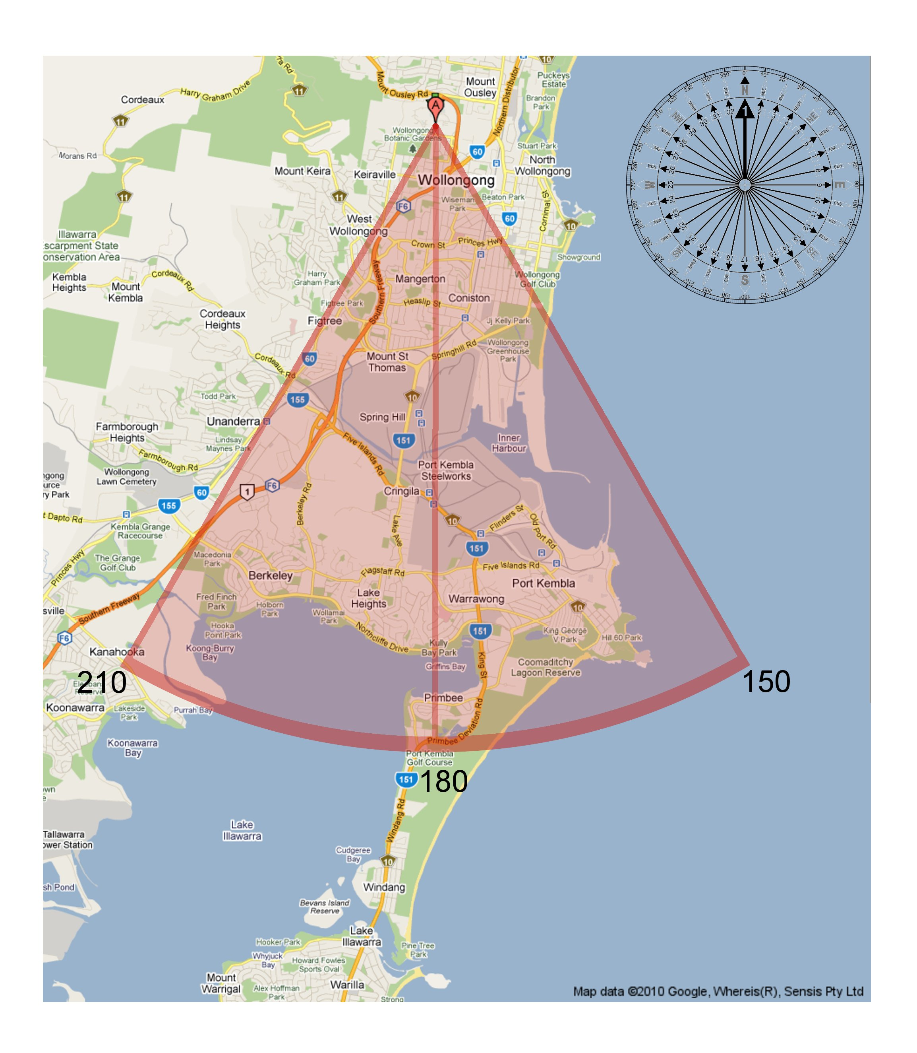
  - The wedge of wind directions likely to transport CO from Port Kembla was determined by overlaying a compass onto a map of Wollongong: 150-210 degrees
  - Air quality data for CO was downloaded from the Department of Environment, Climate Change & Water (DECCW) (http://www.environment.nsw.gov.au/AQMS/search.htm) for the Wollongong station located at Gipps St.
  - Daily averaged total column data was analysed for the weekly average to which it contributed.
  - The number of spectra and time of day contributing to the daily average was analysed in order to help determine likely source of enhancement (e.g. Sydney outflow versus bushfire).

All data was then compiled to determine most likely reasons for event occurrence.

Results:
Tables below show 1) A summary of likely cause of event; and 2) More detailed summary of analysis

1: Wollongong Events: Summary
Event | Date | FTS | MOPITT | Comments
a | 5/00 | y |  | Sydney pollution, local pollution and Port Kembla Steelworks/Shipping.
b | 9/00 | y | y | Unconfirmed high altitude smoke plume, possible Sydney pollution enhancement in FTS.
c | 1/01 | y | y | MZ-4 Australian source. Long range plumes from WA fires, local enhancement due to Sydney pollution and Sydney outflow event.
d | 4/01 | y |  | Sydney outflow pollution event and local pollution.
e | 7/01 | y |  | Atypical data point.
f | 9/01 | y | y | Unconfirmed high altitude smoke plume, possible Port Kembla pollution enhancement in FTS.
g | 1/02 | y | y | Dominated by Sydney fires and FTS enhanced by low plumes from close local fires (Wingecarribee, Wollondilly and Shoalhaven regions).
h | 2/02 | y |  | High CO Column bias in FTS due to single spectra on a day influenced by Port Kembla Steelworks/Shipping.
i | 9-10/02 | y | y | MZ-4 Indonesian source: El Nino fires, Long range, high altitude plumes from African BB. Local enhancement due to local BB (Shoalhaven and Wingecarribee).
j | 12/02 | y |  | Local BB (Shoalhaven, Wingecarribee and Sydney region).
k | 1/03 | y | y | Long range fires at Canberra, possible additional Blue Mountain fire influence.
l | 3/03 | y |  | Sydney pollution and Port Kembla.
m | 8/03 | y |  | Local BB (Shoalhaven region), Sydney pollution and Port Kembla.
n | 12/03 | y | y | Unconfirmed high altitude plume.
o | 9-10/04 | y | y | MZ-4 Indonesian source: El Nino fires`
p | 8/05 | y | y | MZ-4 South American BB. Local enhancement due to Sydney pollution.
q | 9-10/05 | y | y | MZ-4 South American BB; Local BB (above Sydney region), and Sydney pollution.
r | 9/06 | y | y | MZ-4 Indonesian source: El Nino fires. Possible local BB (Wollondilly) enhancement in FTS.
s | 11/06 | y | y | MZ-4 Indonesian source: El Nino fires. High altitude smoke plume from Indonesia, Darwin and Victoria.
t | 4/07 | y |  | Local pollution trapped in an inversion layer.
u | 10/07 | y | y | MZ-4 South American BB; also southern Africa, possible FTS enhancement by small local fires near Sydney and Cooma.
v | 1/08 | y |  | Pt Kembla Steelworks/Shipping, trapped by inversion layer.
w | 5/08 | y |  | Local BB (Shoalhaven) and Sydney pollution.
x | 11-12/08 | y | y | Southerly winds transporting low concentrations of CO combined with local seasonal low.
y | 9/09 | y |  | Pt Kembla Steelworks/Shipping
z | 10/09 | y | y | Southerly winds transporting low concentrations of CO combined with local seasonal low.

2: Wollongong Events: Explanation
Event | Dates of Enhanced CO column | Comments
a | 11/05, 20/05, 21/05 2000 | Trajectories suggest the FTS enhancement on 11/05 may be due to sea breezes creating an inversion layer, thereby trapping local pollution [2], while the trajectories and wind directions on 20/05 suggest enhanced CO due to low altitude plumes from Port Kembla Steelworks/Shipping industry. DECCW for both days also show relatively high maximum CO, supporting FTS data. Time of day of retrieval on 21/05 suggest additional influence from local pollution, on which the FTS operator noted the day was hazy.
b | 13/09, 29/09 2000 | Unconfirmed long range fire event. Differences between instruments mainly due to spatial smearing by MOPITT. Possible slight enhancement of FTS by pollution from Sydney indicated by wind directions during enhanced days.
c | 23/01, 24/01, 25/01 2001 | MZ-4 Australian source. Detection of anomaly by both instruments indicates unconfirmed long range BB plume (possibly WA as indicated by 450 hPa trajectory). Local enhancement seen in FTS is due to Sydney urban pollution plumes on 23/01 and 24/01. The FTS enhancement on 25/01 is likely due to a Sydney pollution outflow event, where pollution from Sydney is transported out over the ocean, and then back over the Illawarra. [2]
d | 05/04, 06/04, 13/04, 17/04 2001 | On the major day of enhancement 05/04 (standard deviation 6.35 from monthly mean) FTS operator noted a milky horizon, and spectra collection times suggest morning local pollution influence. Also, 950 hPa trajectories from ocean indicate likely Sydney outflow pollution event and sea breezes possibly creating an inversion. The 06/04 enhancement is also likely due to Sydney outflow. Trajectories from 13/04 suggest enhancement by local pollution. On 17/04, trajectories and wind suggest Sydney pollution had been pushed towards the Blue mountains followed by [2]. The 450 hPa trajectory is always from the SW for all 4 enhanced days.
e | 02/07 2001 | Only one FTS spectra was recorded for the whole month (9:44 am, 02/07). The retrieval was taken on a hazy day, noted as high haze in the east by FTS operator. The DECCW ground based sensor also noted a relatively enhanced CO day. No fires were nearby according to MODIS. BOM data and BADC back trajectories indicate wind trajectories were from the south, and likely travelled over Port Kembla. All these suggest this day showed CO enhancement due to Steelworks/ Port Kembla shipping industry and/or local pollution. The data point for event e is therefore not a reliable representation of the typical state of the atmosphere over Wollongong for July, 2001. (Note: Cannot confirm whether MOPPIT also saw an event due to no data being available.)
f | 10/09 2001 | Unconfirmed long range fire plume. No local BB. Possible FTS enhancement from Port Kembla Steelworks indicated by wind directions.
g | 02/01, 04/01, 10/01 2002 | Long range plumes from Sydney fires (22/12/2001 – 15/01/2002 according to MODIS) are responsible for enhanced CO total column seen in both MOPITT and FTS data. Local low altitude plumes from local bushfires are responsible for the significantly greater enhancement seen in the FTS data. From 25/12/2001-14/01/2002 the Wollongong escarpment was ablaze, and include all days of enhanced CO. Nearby Shoalhaven, Wollondilly and Wingecarribee districts also experienced fires during this 2 week period. Trajectories during days showing enhancement all travel over the fire regions. (Note: FTS spectra from 01/01 was too full of smoke to be interpreted by SFIT)
h | 22/02 2002 | Only one adequate spectra (11:35 am, 22/02) was recorded on the major enhancement day. Photolysis rates are maximum at approximately noon, which would correspond to maximum rate of CO oxidation by OH radicals, implying a close source of CO at the time of spectra recording. BADC back trajectories and BOM wind data indicate sampled air travelled over Steelworks/ Port Kembla before and during time of sampling, indicating a low altitude plume of pollution from industry is likely responsible for enhanced CO in the FTS data. DECCW data for 22/02 shows a relatively average pollution day, which suggests the FTS retrieval is biased towards high CO, due to lack of several measurements.
i | 10/09, 14/09, 15/09, 02/10, 03/10, 06/10 2002 | Long range plumes suggested by MZ-4 (Indonesian source: El Nino fires). BADC back trajectories also suggest transport of long distance, high altitude smoke plumes from Africa for 15/09. MODIS Fire data confirms fires in Southern Africa around dates of interest. Local enhancement on 14 & 15/09 due to local BB in Shoalhaven region. FTS operator noticed BB smoke and an inversion on 15/09. Local enhancement on 02, 03 & 06/10 due to local BB in Wingecarribee region. Katabatic winds [2] or westerlies may bring smoke over the escarpment during the night as suggested by BOM wind data.
j | 09/12, 22/12 2002 | Local fires observed by MODIS for 09/12 - low-altitude BB plumes from Shoalhaven, Wingecarribee regions and Sydney regions as noted by BOM wind data. Smoke noted by FTS operator on both enhanced days.
k | 09/01, 25/01 2003 | Canberra fires (08/01/2003 till mid February 2003, ~12/02 according to MODIS data) produced long range plumes seen by both FTS and MOPITT. A greater anomaly in MOPITT over FTS is most likely due to the injection of smoke into the stratosphere by pyro-cumulonimbus [3], so the FTS and MOPITT instruments could both detect approximately the same CO total column values. Trajectories for the FTS day of particular enhancement (25/01) suggest long range plumes also from fires in the Blue Mountains as well as Canberra.
l | 28/03, 30/03 2003 | BOM wind data on 28/03 suggest morning Sydney pollution and afternoon Port Kembla pollution enhancements. Back trajectories on 30/03 suggest enhancement from Port Kembla, supported by BOM wind data at time of retrievals. DECCW data.
m | 18/07, 02/08, 15/08, 28/08, 29/08 2003 | 18/07 trajectories and wind directions suggest Port Kembla pollution enhancement. 02/08 wind data suggest Sydney pollution. Local BB in the Shoalhaven region is likely responsible for the last 3 days of enhancement.
n | 19/12 2003 | No event outside the seasonal envelope is shown for the FTS and lack of nearby BB suggest unconfirmed high altitude long range BB plume – possible from WA. DECCW data also confirms a high pollution day. This day may be biased due to only one retrieval.
o | 26/09, 07/10, 11/10, 12/10, 13/10, 28/10 2004 | Long range plumes suggested by MZ-4 Indonesian source: El Nino fires. Differences between instruments mainly due to spatial smearing by MOPITT. Possible local enhancement on 12/10 and 13/10 due to local fires in the Shoalhaven region.
p | 01/08 2005 | High altitude plumes suggested by MZ-4 (South American BB). FTS enhancement on 01/08 due to pollution from Sydney built up over Blue Mountains at night then transported over Wollongong as suggested by BOM wind data. DECCW data confirms a high pollution day.
q | 07/09, 08/09, 21/09, 10/10 2005 | High altitude plumes indicated by MZ-4 (South American and possible BB local sources) For enhancements on 07 and 08 /09, 950 hPa trajectories originate over Sydney spot fires, as identified by MODIS. For 21/09, wind data suggests enhancement due to Sydney pollution. 10/10 Pollution from Sydney built up over Blue Mountains at night then transported over Wollongong as suggested by trajectories and BOM wind data.
r | 16/09 2006 | Long range plumes suggested by MZ-4 Indonesian source: El Nino fires. Differences between instruments mainly due to spatial smearing by MOPITT. Possible local enhancement on 16/09 due to local fires in the Wollondilly region. All levels of back trajectories suggest air moved over this region, which is further supported by BOM wind direction at time of retrieval.
s | 01/12, 04/12 2006 | No statistically significant enhancements (>1 standard deviation) were found in the November FTS retrievals. However, enhancement day 01/12 in early December was included in the final November weekly average. (Note: Recorded smoke plume with Darwin FTS on 30/11, which is where high trajectories are indicated to have originated). Long range plumes suggested by MZ-4 Indonesian source: El Nino fires. Differences between instruments mainly due to spatial smearing by MOPITT. However, some further FTS enhancement may be due to long distance plumes at 700 hPa travelling over Victoria on both enhanced days, while higher altitude back trajectories over Victoria were only indicated on 04/12.
t | 11/04 2007 | BOM wind data and BADC trajectories suggest sea breezes create an inversion layer, trapping local pollution, as noted by FTS as white haze.
u | 14/10, 16/10, 18/10 2007 | Long range plumes suggested by MZ-4 (South American BB; also southern Africa). BADC back trajectories from Africa confirmed on 14/10. Differences between instruments mainly due to spatial smearing by MOPITT. Possible enhancement in FTS due to fires in Sydney region and Cooma region.
v | 07/01 2008 | Wind trajectories and BOM wind data suggest sea breezes create an inversion laye which then traps pollution from Port Kembla.
w | 23/05, 27/05, 29/05 2008 | 23/05 Local BB in Shoalhaven region with BOM wid data and trajectories supporting plume from this direction. 27/05 Pollution from Sydney built up over Blue Mountains at night then transported over Wollongong as suggested by trajectories and BOM wind data. 29/05 wind directions directly from Sydney at time of retrievals.
x | 21/11, 22/11, 14/12 2008  (Low anomaly) | Three very low retrievals show trajectories originating from the south. These southerlies are likely transport lower CO concentrations from the southern latitudes, due to the latitudinal gradient in CO [4-6]. Transport combined with a local seasonally low average, produced the observed low event. DECCW data supports low CO event.
y | 18/09 2009 | Trajectories and wind data at retrieval time on day of enhancement suggest pollution from Port Kembla. Note that on the day of enhancement, only one spectra was recorded. DECCW data shows an average CO pollution day which suggests this point is likely biased towards high values. Dapto fires shown up in later dates in MODIS, BOM data shows northerly wind during these fires, accounting for the low retrievals on these days.
z | 06/10, 07/10, 08/10, 14/10, 15/10, 16/10, 19/10 2009  (Low anomaly) | Five retrievals less than 1.2E18 all show trajectories from the south, which spend a majority of time over the southern oceans. These southerlies are likely transport lower CO concentrations from the southern latitudes, due to the latitudinal gradient in CO [4-6]. Transport combined with a local seasonally low average, produced the observed low event. DECCW data supports low CO event.(Note: Also see a low anomaly in Darwin around the same time) On the only day of enhancement, The 950 hPa trajectory spent time over Sydney before moving to Wollongong.

References:

1. http://eosweb.larc.nasa.gov/GUIDE/campaign_documents/mopitt_project.html#char
2. Bryant, E. A., "Local climate processes in the Illawarra" (1982). Wollongong Studies in Geography. Paper 11. http://ro.uow.edu.au/wollgeo/11
3. Murphy, C., Measurements and Modelling of Emissions from Biomass Burning in Australia, PhD Thesis, University of Wollongong, pg 83, 2009 (Original reference: Fromm, M., et al., Geophys. res. lett. 33 (5), 2006)
4. Yashiro, H., S. Sugawara, K. Sudo, S. Aoki, and T. Nakazawa, Temporal and spatial variations of carbon monoxide over the western part of the Pacific Ocean, J. Geophys. Res., 114 (8), D08305, 2009.
5. Holloway, Tracey; Levy, Hiram, II; Kasibhatla, Prasad, Global distribution of carbon monoxide
J. Geophys. Res., 105 (D10), pp. 12123–12147, 2000.
6. Novelli, P. C.; Masarie, K. A.; Lang, P. M., Distributions and recent changes of carbon monoxide in the lower troposphere, J. Geophys. Res., 103 (D15), pp. 19015–19033, 1998.

Appendix: Notes

Notes to self: Urban Air is 1-30 ppm CO (From Emma)
Natural Background: 40-120 ppb CO (ref:Wayne, Chemistry of Atmospheres)

Location | Latitude | Longitude
Canberra | -35.18 | 148.10
Port Kembla | -34.26 | 150.54
Port Kembla Steelworks | -34.46 | 150.88
University of Wollongong | -34.406 | 150.879
Sydney (~ Airport) | -33.94 | 151.18
Newcastle | -32.93 | 151.78

My basic interpretation of the story of the three sites:
    - Lauder – Clean background site, influenced by long range biomass burning
    - Darwin – Major influence from biomass burning both local and long-range, large Savannah grass fires, tropical Indonesian fires (Melita @ CSIRO Cape Grim presentation showed there is always smoke around, even if you can't physically see any)
    - Wollongong – Influences from local urban environment, Sydney, Local Steelworks, (Shipping Port?), local biomass burning and long-range biomass burning.

In terms of data scatter 3 > 2 > 1 (observation) Determined by topography and types of contributions to enhancement?

