CONNECTING AIR QUALITY AND CLIMATE OVER INDONESIA

David Edwards
National Center for Atmospheric Research
Boulder CO, USA

James Drummond
Dalhousie University
Halifax NS, Canada

15 Dec. 2006

The last few months have seen very poor air quality over Indonesia due to intense smoke from numerous fires on the islands of Sumatra and Borneo. In October, the regional impact of the pollution resulted in the Indonesian president apologizing to neighboring countries as the air pollution index in several cities reached “dangerous” levels. The smoke consists of particulate pollutants (aerosols) such as soot in addition to other trace gases such as carbon monoxide (CO). Carbon monoxide is a very good pollution indicator since it is produced during combustion processes such as the burning of fossil fuels in urban and industrial areas as well as by wildfires and agricultural burning. Carbon monoxide and other fire pollutants also increase the concentration of ground-level, “bad” ozone.

Satellite remote sensing provides a useful way to investigate the impact of these intense fires on the regional and global air quality. Fig. 1 is a false-color image showing the global view of CO pollution levels at an altitude of roughly 3 km (700 millibars) as seen from space, with data collected during the month of November 2006 by the joint Canadian/U.S. Measurements Of Pollution In The Troposphere (MOPITT) mission aboard NASA’s Terra satellite. A large plume of CO is seen flowing from the Indonesian Islands and spreading out into the Indian Ocean. This results in the most intense pollution feature in the world at this time.

Some burning takes place in Indonesia every year, although the number and intensity of the fires varies significantly, and consequently the amount of pollution that is generated changes year-to-year. Investigators at the National Center for Atmospheric Research (NCAR), the NOAA Earth System Research Laboratory and Toronto University have investigated these variations using the MOPITT data record since the Terra satellite deployment in 1999. This research was recently reported in the Journal of Geophysical Research. Looking at the CO pollution loading over the Indonesian region, the team led by David Edwards at NCAR saw distinct spikes in some years. This is shown in the top panel of Fig. 2 where high CO occurs from September to November at the end of 2002, 2004, and this year, 2006. The team showed that the high CO pollution emissions from the large number of Indonesian fires in these years often travels very great distances and determines the inter-annual variability of pollution levels throughout the Southern Hemisphere.

The dense tropical rainforests of Sumatra, Kalimantan, and Malaysia only burn in years with below average rainfall when significant drying occurs. The fires normally originate in agricultural activities and often spread out of control. Despite ongoing efforts by the Indonesian government to control burning, many fires are still started illegally as a cheap way to clear land for plantations. Particularly in Sumatra and Kalimantan, there is an added concern that significant forest clearing and drainage threatens the stability of peat deposits - thick layers of extremely flammable partially decayed vegetation matter that build up at the forest floor. This makes them particularly susceptible to fire during periods of drought and a smoldering burn that releases large amounts of carbon into the atmosphere often continues until the onset of the monsoon rains at the end of the year. Drought periods over Indonesia are often brought on by the shift in the atmospheric circulation over the topical Pacific associated with El Nino conditions. The bottom panel of Fig. 2 shows the NASA GSFC Global Precipitation Climatology Project (GPCP) El Nino Southern Oscillation Index. This shows that significant El Nino conditions (positive red values) closely match the occurrence of high CO pollutant loadings in 2002, 2004, and 2006. Even thought the current El Nino is considered mild, it has led to significant pollution over Indonesia and neighboring countries. In addition to CO, the fires also produce significant amounts of the greenhouse gas carbon dioxide (CO₂). This suggests that not only is there a direct link between climate variability and the deterioration of regional air quality, but a potential for further climate impact.

Reference:
Edwards, D. P., G. A. Pétron, P. C. Novelli, L. K. Emmons, J. C. Gille, and J. R. Drummond (2006), Southern Hemisphere carbon monoxide interannual variability observed by Terra/Measurement of Pollution in the Troposphere (MOPITT), J. Geophys. Res., 111, D16303, doi:10.1029/2006JD007079.

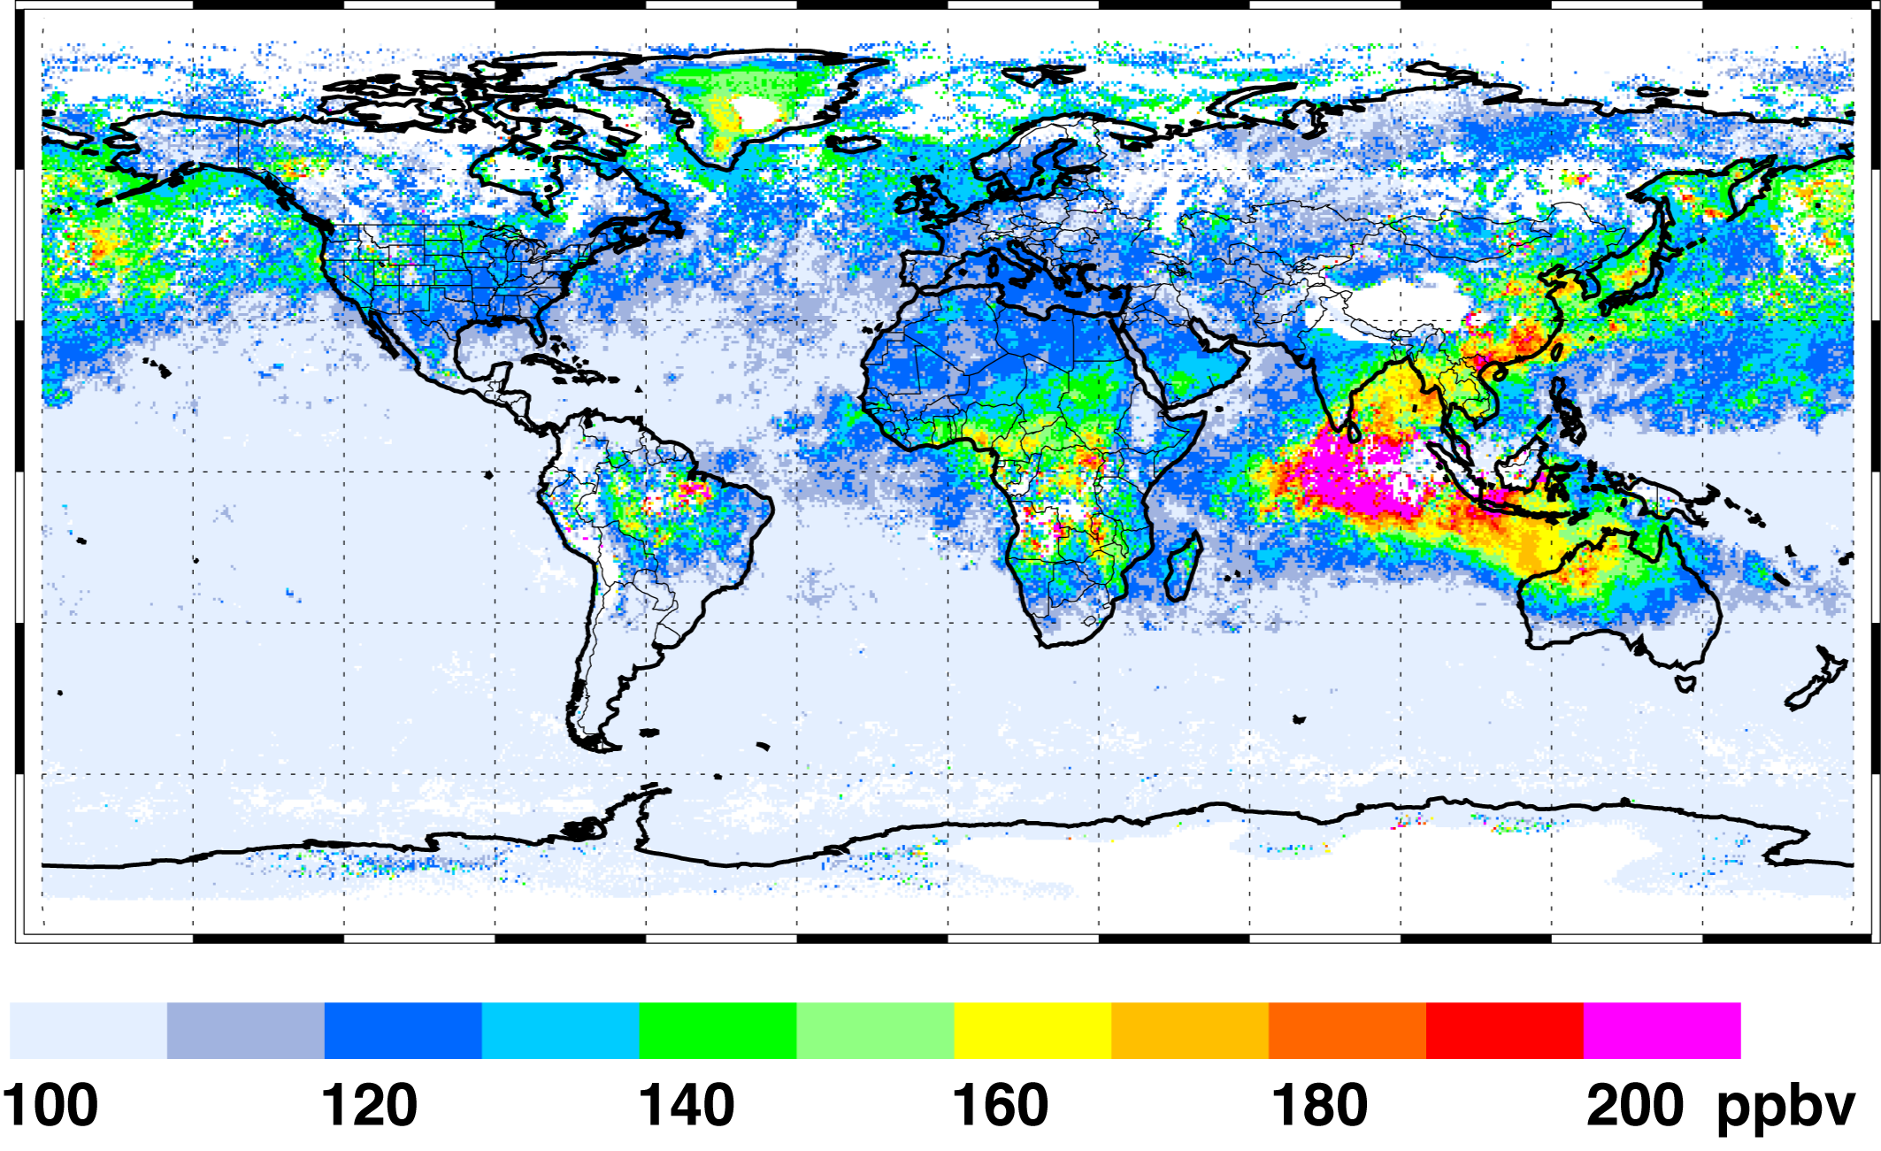

Fig. 1: The November 2006 global average distribution of atmospheric carbon monoxide at an altitude of about 3 km as measured by the MOPITT instrument aboard NASA’s Terra satellite. High levels of CO pollution are shown in red. The large plume of pollution from Indonesian fires is clearly visible. Some carbon monoxide from fires in northwestern Australia and end-of-season fires in the South American Amazon and southern Africa is also apparent, as are persistent plumes of industrial pollution leaving China and out over the Pacific Ocean toward North America. MOPITT data courtesy of the NCAR and University of Toronto MOPITT teams.

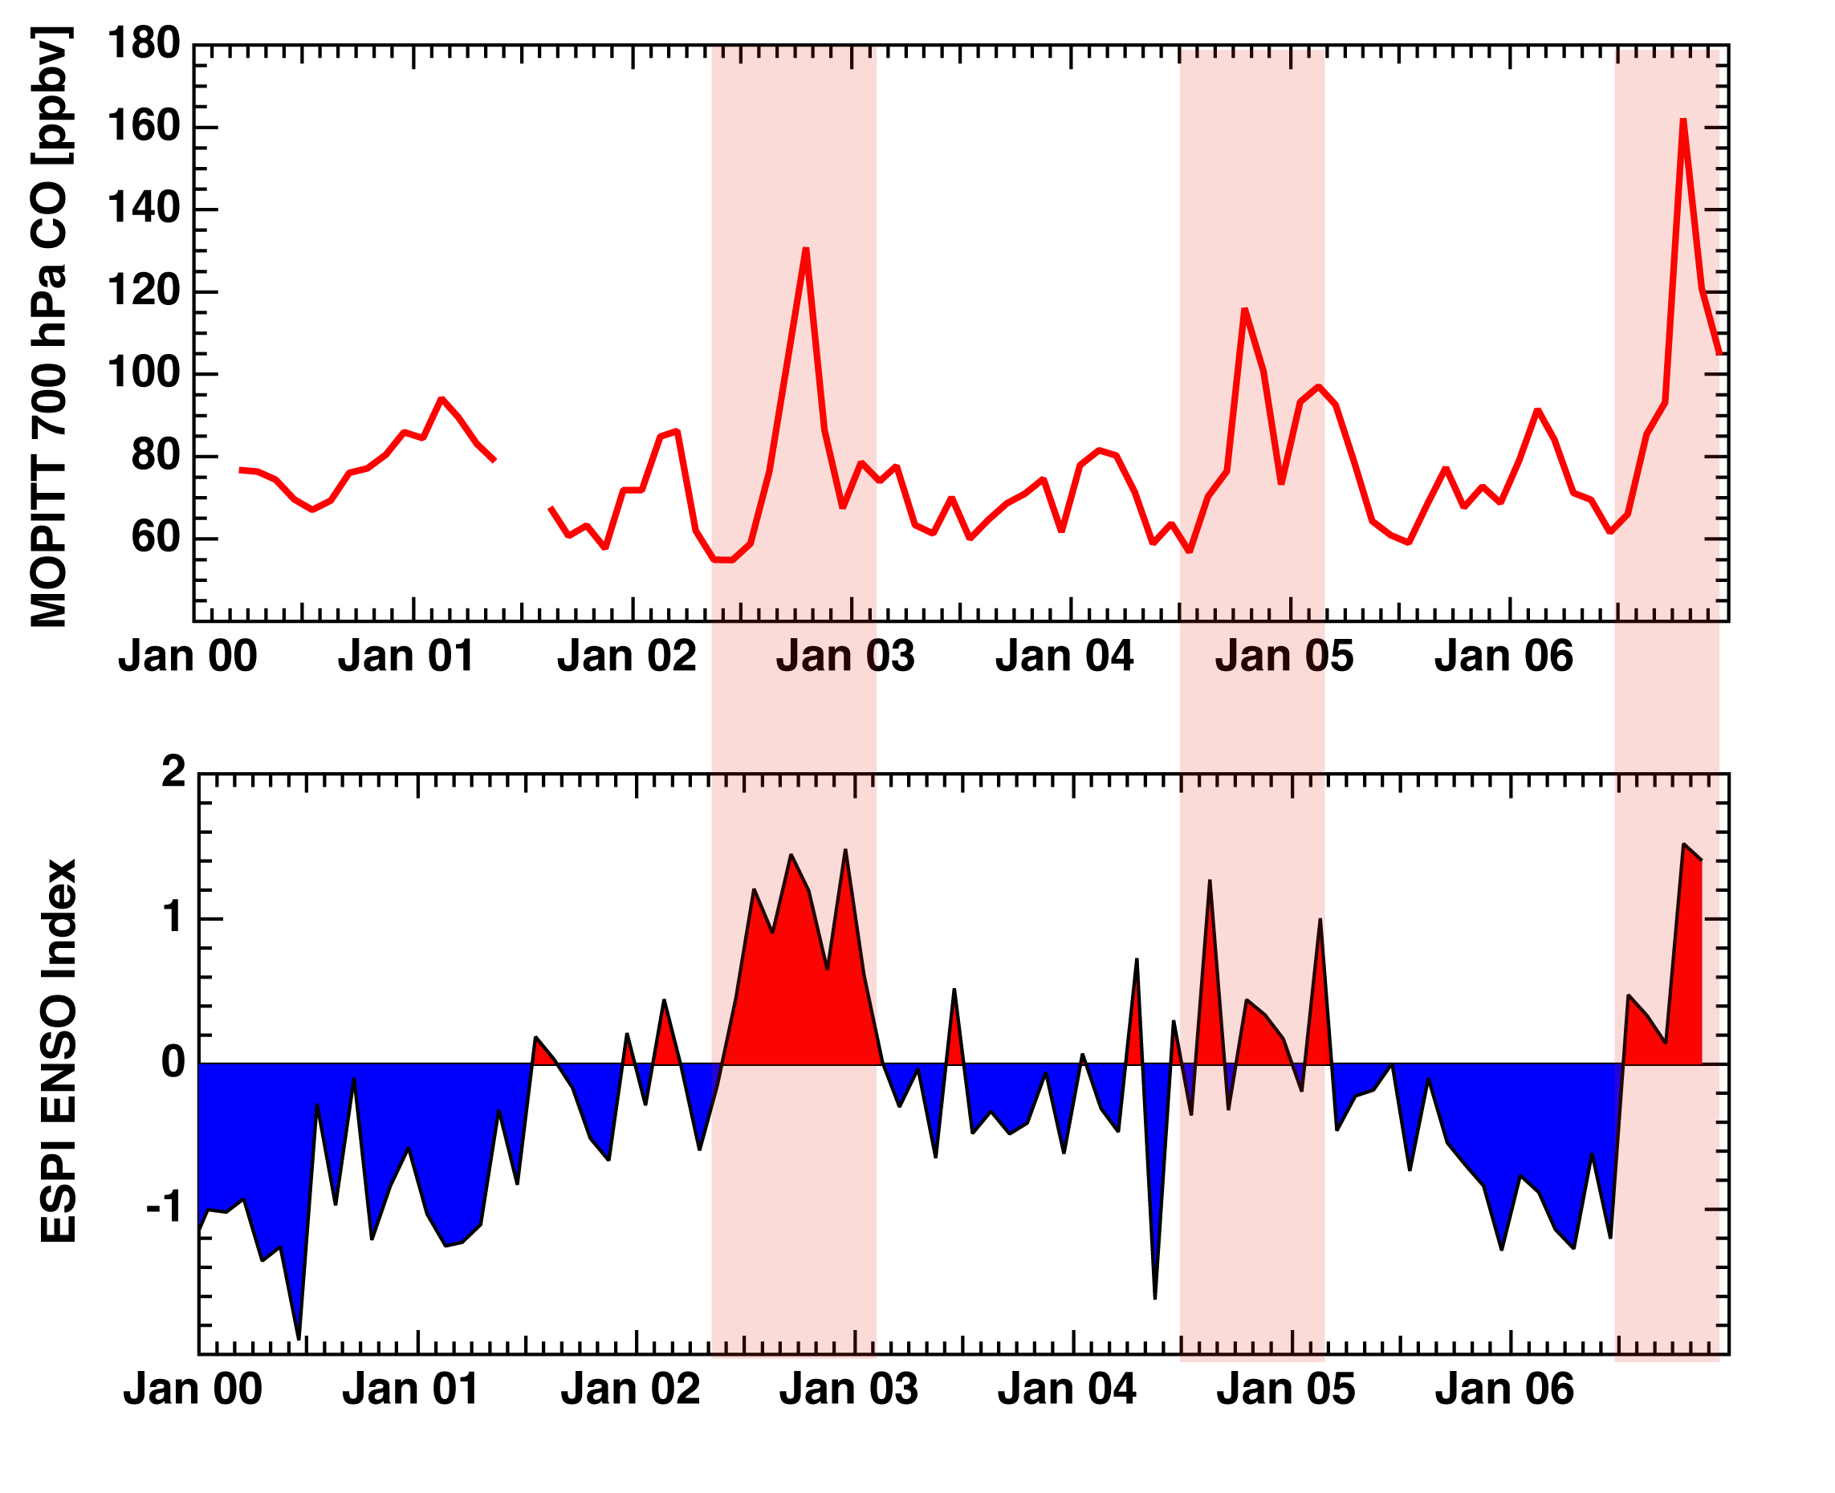
Fig. 2: TOP, The inter-annual variability of the MOPITT atmospheric carbon monoxide mixing ratio (ppbv) at an altitude of about 3 km over the Indonesian region (10S-5N, 90E-160E) and BOTTOM, the El Nino precipitation index. El Nino warm phase conditions that lead to a reduction in rainfall and an increase in fire occurrence over Indonesia are in red. MOPITT data courtesy of the NCAR and University of Toronto MOPITT teams. El Nino index data courtesy of the NASA GSFC Global Precipitation Climatology Project.

